

***Table of Contents:***

* **Overview ……………………………………………………………… 2**
* **Race Location / Directions ……………………………………. 3**
* **Registration / Qualification / Lottery / Refunds ……. 4-6**
* **Solo Division Info …………………………………………………. 7-8**
* **Lodging ………………………………………………………………… 8-9**
* **Schedule of Events ………………………………………………. 10-11**
* **Race Rules …………………………………………………………… 12-14**
* **Course Information ……………………………………………… 15-16**
* **Aid Station Chart …………………………………………………. 17**
* **Overall Course Map …………………………………………….. 18**
* **Overall Course Profile ………………………………………… 19**
* **Segment Leg Maps with Elevation Profiles ..……….. 20-25**
* **Turn by Turn Directions ………………………………………. 26-28**
* **Drop Bags …………………………………………………………… 29**
* **Pacer Information/Rules …………………………………….. 30**
* **Crew Information/Directions ……………….……………… 31-35**
* **Awards ………………………………………………………………… 36**
* **Frequently Asked Questions (FAQ’s) *……………………* 37-41**
* **Sponsors …………………………………………………………….. 42**
* **Useful Information Links: ……………………………………. 43-45**



***Overview***

***Welcome***

On behalf of the Race Directors, Volunteers, and Sponsors, welcome to the Annual San Diego 100 Mile Endurance Run (SD 100). The SD 100 was founded by Paul Schmidt in 2001 and has grown in popularity with entrants coming from across the US and numerous international countries.

The event maintains a 300 runner limit with qualification standards required to apply for entry. A lottery may be required to select the starting field due to higher demand than permits allow. A waitlist is maintained once the 300 entrant limit is reached.

Registration information and everything you need to know about the event is contained in this Runner Handbook and the race website at www.sandiego100.org .

We’re committed to do our best to help prepare you to successfully run a tough and challenging 100 miles in the beauty of the San Diego east county mountains. We look forward to another great race in the east county mountains of San Diego.

***Race Location/Directions***

The San Diego 100 starts and finishes at Lake Cuyamaca located 9 miles south of Julian, CA. The south parking lot of Lake Cuyamaca serves as the race venue for packet pickup, check-in and the pre-race briefing. Lake Cuyamaca is located at: 15027 Highway 79, Julian, CA 92036. **Directions Link: goo.gl/QGr4JH**

***Registration / Qualification***

**Cancellation Policy:** If for any reason the event is cancelled due to an act of nature or other Forest Service permit issues, the race director will make every effort to refund all unobligated funds to entrants or roll over entry fees to a rescheduled race date. Entrants must accept the fact that there are risks involved in staging an ultra in the wilderness and there are no guarantees that all entry fees will be refunded if the run is not held as advertised.

**Qualification to Apply:** To apply for the race each year, applicants must have completed an official 50 mile race within a 13-hour time limit. A 100K or a 100 mile race within the race finishing time also serves as an acceptable qualification. You have until April 1, 2022 to achieve your qualification. The results of the qualification must be verifiable on Ultrasignup or annotated on an official web site of the race used for qualification.

As a requisite for participation, entrants are required to volunteer 6-hours towards trail maintenance, or volunteer work at any running or community service event. This requirement must be completed within one year of the event (June 1), and certified to the Race Director by mail or email to sandiego100rd@gmail.com once the service is completed.

A list of completed volunteer service completions is maintained and updated weekly.

In lieu of completing trailwork (or in addition!), a runner may donate $100 to support SURF, trailwork, and our volunteers in lieu of the 6 hours of volunteer work. San Diego Ultra Friends (SURF) is partnering with the United States Forest Service to make certain improvements to the trails in the Mount Laguna Recreation Area including many of the trails on which the race is run. As part of this project, SURF is funding the placement of directional signs throughout the area to enhance the enjoyment of all trail users. Should you choose to donate in lieu of volunteer work, your donation will help fund this project for all to enjoy for many years to come.



We hope and encourage the greater San Diego area SD 100 participants to complete their volunteer service in the east county San Diego trails we use for the 100 miler. Information about the San Diego Trailfit program and how to sign up for a workday are located at <https://www.sdtrailfit.org> .

**Registration Application:**

Applicants have a four-day entry period to apply. Once applications are closed, if necessary, a lottery is conducted to select the 300 runner entrant field. Lottery results are posted within a few days after the lottery. Entrants will be notified of their selection. Non-selectees will then have to opportunity to sign up on the wait list immediately following the official posted entrant’s list on Ultrasignup. Should a lottery not be necessary, a waitlist will be maintained once the 300 runner entrant field is filled.

**C:\Users\scottemills\Documents\2018 San Diego 100\Ultrasignup Logo 2.png**

**Entry Fee / Refunds:**Entry to SD 100 is $280 plus the Ultra Signup fee (approximately $18). If an entrant withdraws from the event and notifies the race director prior to April 1, they will receive a 50% refund minus the Ultrasignup fees. If an entrant withdraws after April 1 and before April 15, they are entitled to a receive a $100 refund minus the Ultrasignup fees. No refunds after April 15. No rollovers or transfer of entries once an applicant is a confirmed entrant unless a runner becomes pregnant for which we will gladly roll over an entry into the following year.

***Solo Division***

1. Entrants declare their intent to enter the Solo Division (S) when they register. Anyone can change to Solo or Supported (NS) before June 1 by notifying the RD.
2. Solo Division runners are not allowed to have crew or pacers assist them throughout the race. They rely solely upon the official aid stations and their drop bags.
3. Solo Runners are not allowed to have spectators at any aid station other than the start and finish, and as such, will not be given a pacer bib or crew vehicle placard at check-in.
4. Solo Runners are allowed to run with other runners and/or their pacers but cannot rely on them (other than in an emergency) for support.
5. If entrants violate the Solo Division Rules, they are not disqualified from the race but will no longer be recognized as a Solo Division finisher.
6. All Solo Runners will wear a wristband to distinguish them in the Solo category. Solo runners will not receive a crew pass or pacer bib at check in since they have no access to either.
7. Runners may not change to supported during the race.

SOLO finishers will be awarded special award the SOLO FINISHER Belt Buckle for their accomplishment of tackling the 100 mile course unassisted.

***Lodging / Camping / RV’s***

Lake Cuyamaca, Cuyamaca Rancho State Park, and Julian, CA are very popular vacation destinations in early and mid-June. Make your reservations early in your planning or you may have difficulty finding lodging for race weekend.

Lake Cuyamaca has rental facilities for campsites and RV's. Several of the cabins and condos are already reserved to accommodate weekend volunteers; however, there are a few available if you reserve early. Reservations and deposits are for staying at Lake Cuyamaca: [**www.lakecuyamaca.org**](http://www.lakecuyamaca.org).Or you can call at 760-765-0700 for reservations. Be sure to let them know you are with San Diego 100.

There are several lodging options available in the nearby town of Julian which is only 9 miles from the start. The **Julian Chamber of Commerce website** has many possibilities: [**http://www.visitjulian.com**](http://www.visitjulian.com).

**Cuyamaca Rancho State Park (Paso Picacho Campground)** is only 3 miles from Lake Cuyamaca and has campsites and cabins to rent:[**http://www.reserveamerica.com**](http://www.reserveamerica.com)

Also check out **Mt Laguna Lodge** for accommodations in the Mt Laguna Recreational Area section of the race (about 18 miles from Lake Cuyamaca but near many of the middle aid station locations): [**www.lagunamountain.com**](http://www.lagunamountain.com)

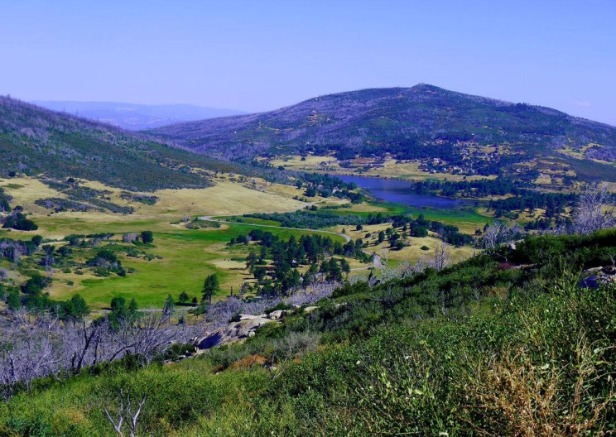

***Schedule of Events for 2022***

**Thursday, June 2, 2022**

* 2:00 pm - 5:30 pm: Bib pick-up at Lake Cuyamaca south parking lot.

**Friday, June 3, 2022**

* 4:30 am - 5:30 am - Check in and bib pick up to get last minute details, pick up your bib, and deposit drop bags. ARRIVE EARLY - PARKING IS EXTREMELY TIGHT! The later you arrive the further you will have to walk to get to the start. There is no parking along Hwy 79 so if you arrive late, you will have to walk upwards of a half mile from an available and legal parking location. You must check in, even if you got your bib the day before! We need to know who is on the course for your safety.
* 5:15 am: All Drop Bags must be deposited at appropriate aid station bin next to the Registration Tent. Drop bags that do not meet the 16 x 12 x 6 size limitations will not be accepted. Drop Bags will be organized by number and aid station, so please pay attention where you leave your Drop Bag. Drop Bags should be labeled with runner number and aid station. Drop Bags leave venue at 5:30 am!
* 5:50 am: Final Race Briefing in front of Start Banner.
* 6:00 am: Race Start in front of Registration Tent. We will not allow any runners to start late since sweep runners will be removing marking ribbons just behind the last runner/s.

**Saturday, June 4, 2022**

* 12:00 am to 6:00 am: Sub-24 hour finishers arrive at finish line and receive their **SUB-24** hour buckles.
* 6:00 am to 2:00 pm: Sub 32-hour finishers receive their **FINISHER** buckles.
* 8 AM. Beginning of food service and party at finish line.
* Solo Runners who finish under 32 hours receive **SOLO** buckle.
* Light food and refreshments will be served beginning midnight Friday with more hearty fare beginning at 8 AM until the event ends. Food and refreshments are for runners, crew, volunteers, and family. We encourage everyone to relax, have fun, and enjoy seeing the runners achieve their dreams.

**SATURDAY, JUNE 11, 2022**

**Post Race Fiesta!** – Follow us on social media and read our e-mails to find out where this will be. Come share stories and thank all your volunteers who helped make your race possible. In the past, anyone wearing SD 100 gear from 2022 gets $1 off all their full pour beers. And our volunteers drink for free! There will be food trucks for the hungry and beer for the thirsty. We hope to see you there to shake your hand and say congratulations for the great effort.

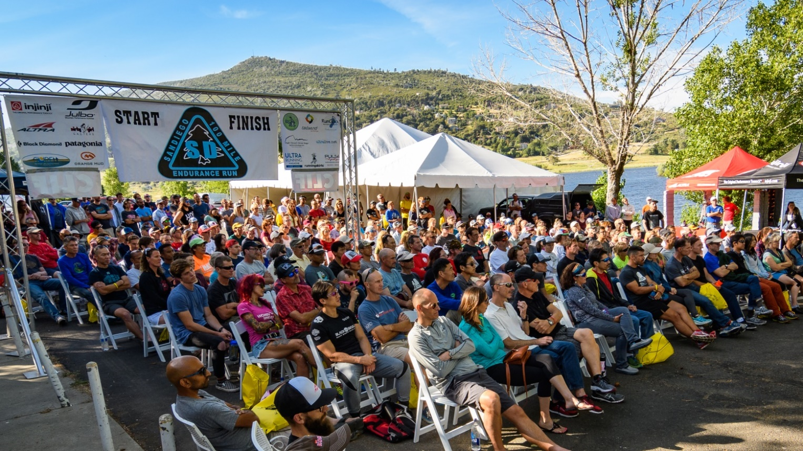

***Race Rules***

**Getting Lost, Cutting the Course, and Cut Off Times**

1. SD 100 is a “Closed Course” You must follow the official course or you are not an official finisher.
2. If any runner gets lost or cuts the course, they’re required to return to the point at which they went off course by their own means and continue the run from that point. If a runner does not return to that point or continues on after cutting a section of the course, they are disqualified.
3. Runners who do not make the mandatory cut off times as written on the Course Information Chart are also DQ'd. The Aid Station Captain exercises the authority of the Race Directors. They have the authority to pull a runner from the race if they feel it is unsafe for the runner to continue. Please do not argue with the aid station captain's decisions. If an Aid Station Captain determines that it is unsafe for you to continue, you must surrender your race bib. Arguing with the Aid Station Captain may result in the runner not being allowed to participate in any future San Diego 100 or San Diego Slam race.
4. **Dropping out of the race:** If a runner drops from the race for any reason, it is the runner's sole responsibility to personally notify the nearest aid station captain that he or she is withdrawing from the race. **The runner is also required to physically remove and give their race bib to the aid station captain**. Failure to notify an aid station that you are out of the race and failure to turn in your bib # may result in costly search and rescue measures which will be the responsibility of the runner.
5. Failure to abide with any of the rules or decisions of the aid station captain will result in you not being allowed to participate in any future SD 100 or San Diego Slam race.

**Littering**

Dropping litter anywhere on the course is strictly prohibited. Carry all trash to the next aid station and dispose of it in the appropriate receptacles.

If you happen to see a gel pack or other race related litter that was accidentally dropped, please pick it up for us and dispose at next aid station. Thank you for keeping our trails litter free!

**Relieving Yourself**

If you must relieve yourself, get off trail and out of sight. Bury and cover solid waste and toilet paper properly. LEAVE NO TRACE! There are bathrooms or porta-potties at Lake Cuyamaca, Paso Picacho, Chambers, Sunrise 1/2, Pioneer Mail 1/2, Red Tailed Roost, Cibbets Flat and Meadows.

**Medical Issues**

You are responsible for your own safety. We have a medical director and will have medical care volunteers during the run. We have trained several people at our expense in CPR and wilderness first aid to try to ensure your safety. But they are not located at every aid station. Ultimately, YOU ARE RESPONSIBLE FOR YOUR OWN HEALTH AND SAFETY. In case of an emergency, we will endeavor to get local emergency personnel to an injured runner (or vice versa) as soon as possible, but due to the remoteness of the course, this could take hours. This is an event with risks. Please thoroughly read the registration waiver and recognize it is up to you to make wise decisions with regards to health and safety.

The race has liability insurance only. This is insurance covers litigation over negligent acts and does not cover medical costs incurred by the runner. If you do not have medical insurance, we recommend you join USATF. This race is sanctioned and insured by USATF and members may be able to be reimbursed for medical costs (with a cap of about $6k) if the medical condition was not due to negligence on the part of the runner. For more information, check out USATF’s on line web site.

**Pets**

For liability insurance purposes and permits, dogs are not allowed at aid stations or on the course. Dogs will be allowed in a very restricted area in the shade away from the runners at the start finish venue. This rule will be **strictly** enforced. Dogs are also not allowed on California State Park trails. It is the runner's responsibility to brief and inform your crew and/or spectators of this restriction. This has in the past resulted in penalties for the runners.

Beyond all this, it is likely going to be hot during the race, and you will be endangering your fuzzy friend by bringing him or her to the race as a car is not a great place for a dog during the summer. Do your dog and runner a favor and leave the pups at home.

**Smoking**

Please no smoking at aid stations or the start finish venue.

***Course Information***

* The SD 100 course covers 5 major areas: Lake Cuyamaca, Rancho Cuyamaca State Park, Mt Laguna Recreational Area, Pacific Crest Trail (PCT), and the Noble Canyon and Indian Creek Trails.
* The trails are under the jurisdiction of the US Forest Service Descanso District (75%), the California Rancho Cuyamaca State Park (20%), and the Lake Cuyamaca Recreational Area (5%).
* The course is approximately 80% single track trails, 17% forest service roads and 3% asphalt road. There are some technical and rocky sections (mostly in Noble Canyon). The PCT sections total about 42 miles of the course. The overall elevation climb and descent are approximately 13,000 feet each.
* Runners should be totally familiar with those sections that are bi-directional (course travels one direction outbound and then the opposite direction inbound). Pay very close attention to applicable course markings and review the overall course map so as to have the big picture of the course. There have been instances of course marking vandalism in past races. As such, we recommend carrying a copy of the course maps and/or detailed route directions for sections that you are unfamiliar with. Moreover, there are course videos which the course director has made which show all major turns on the course (and some not-so major). Do yourself a favor and check these out along with the maps and turn by turn directions. You will stand a much better chance of finishing or meeting your goals if you take these simple preparations.

***Aid Station Chart***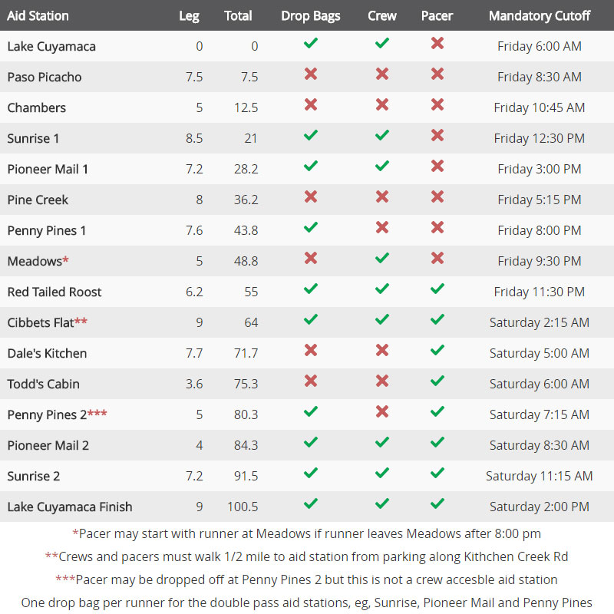

***Overall Course Map***

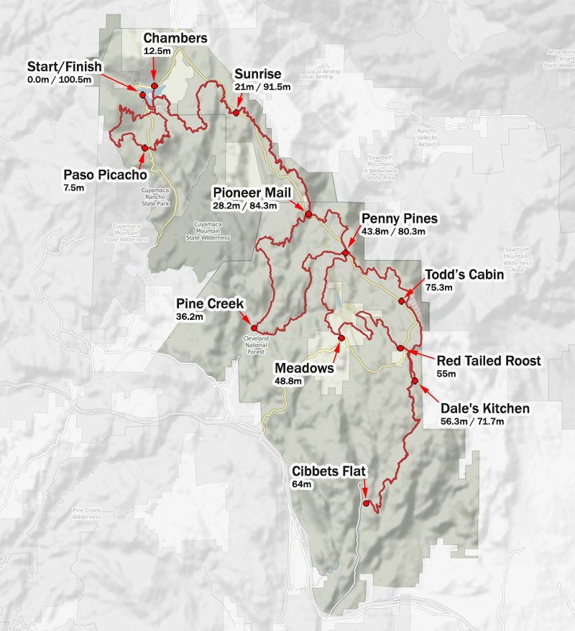

***Aid Station with Profile Elevation***

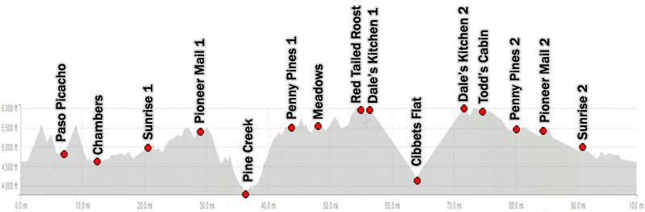

***Segment Leg Maps with Elevation Profiles***

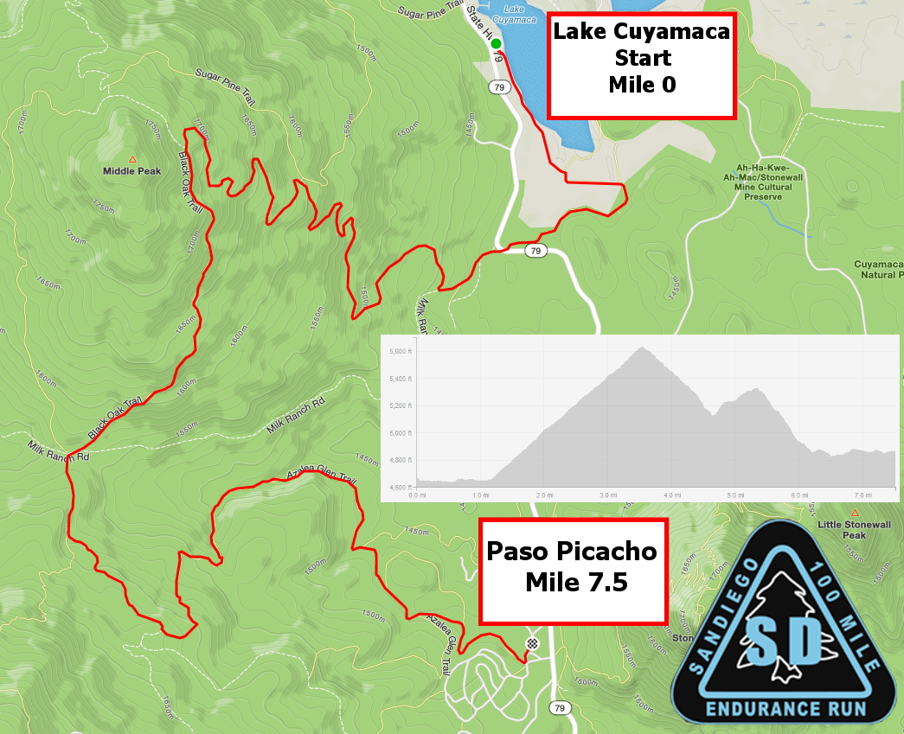

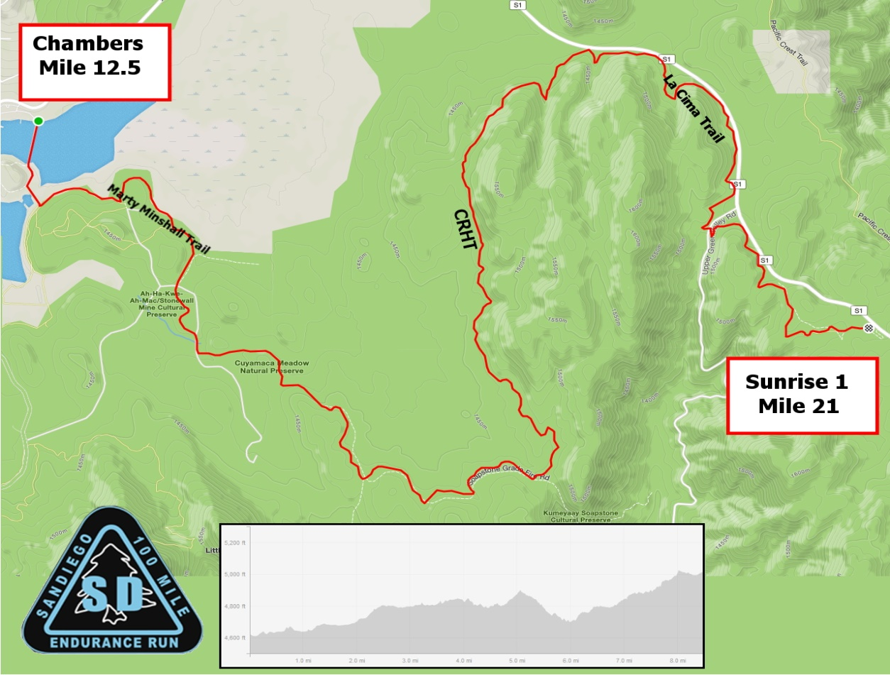

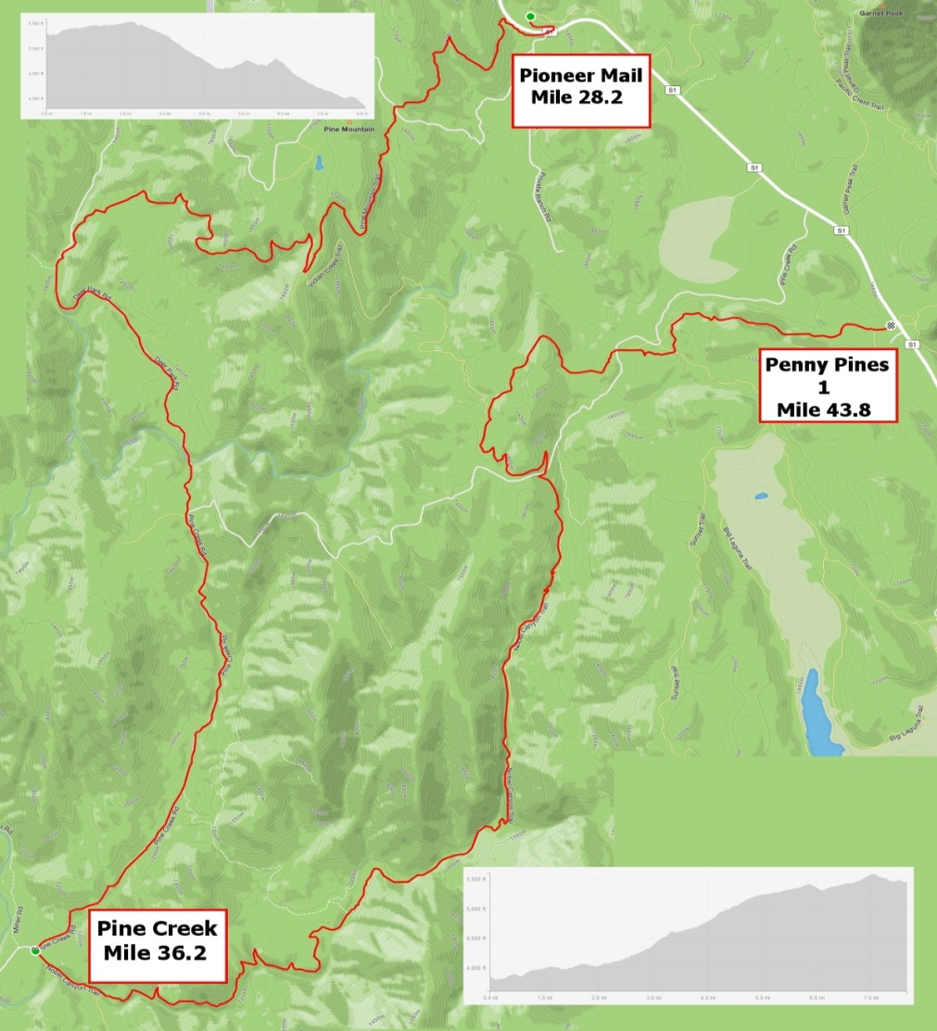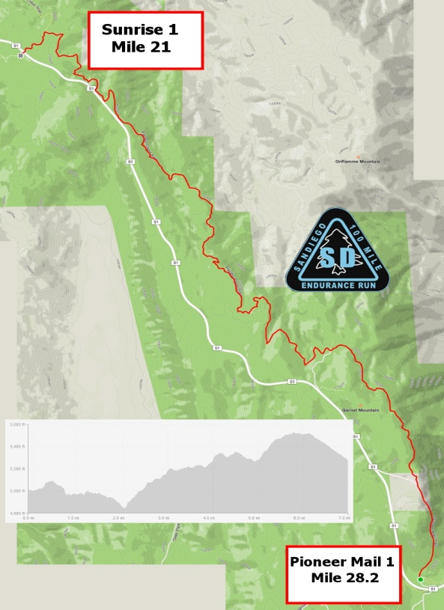

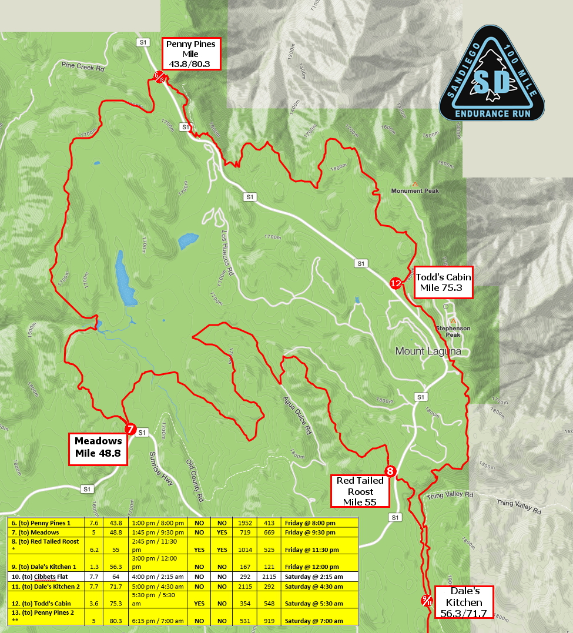

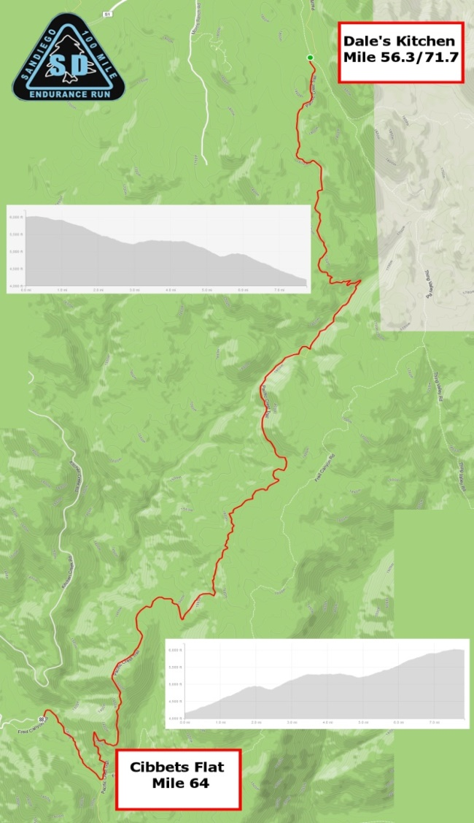 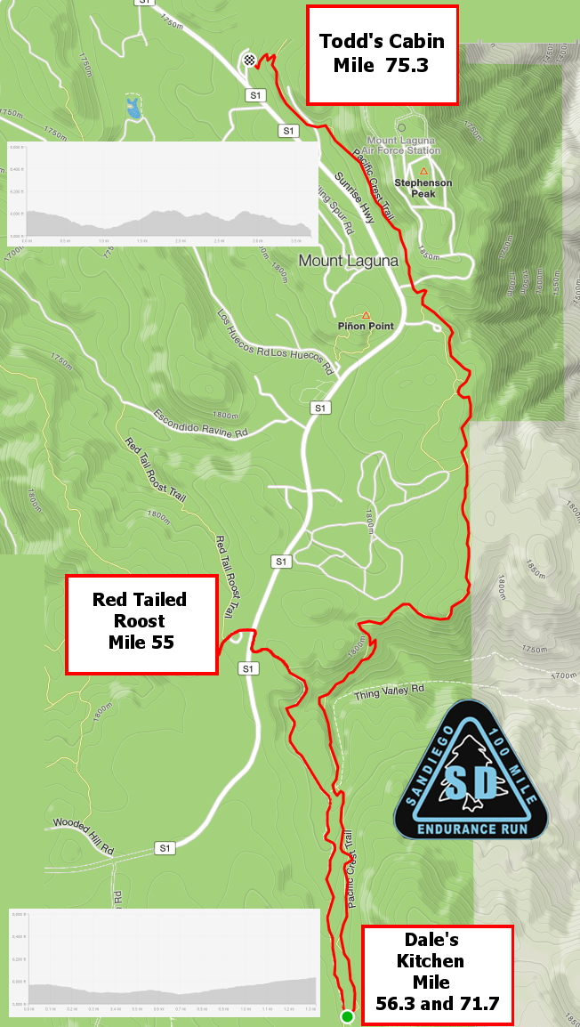

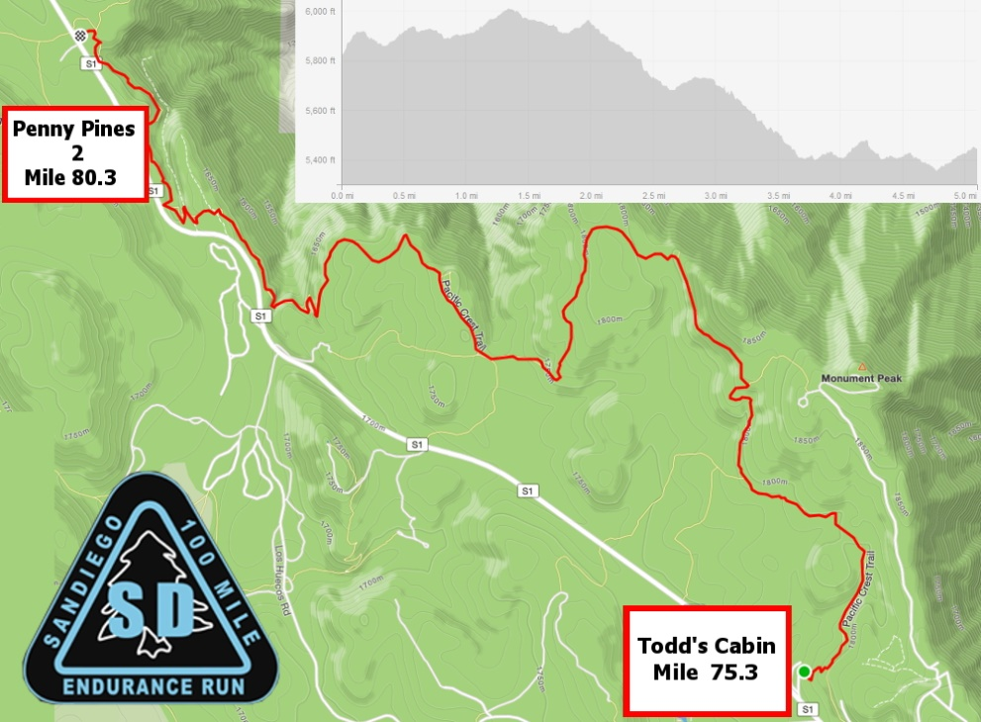

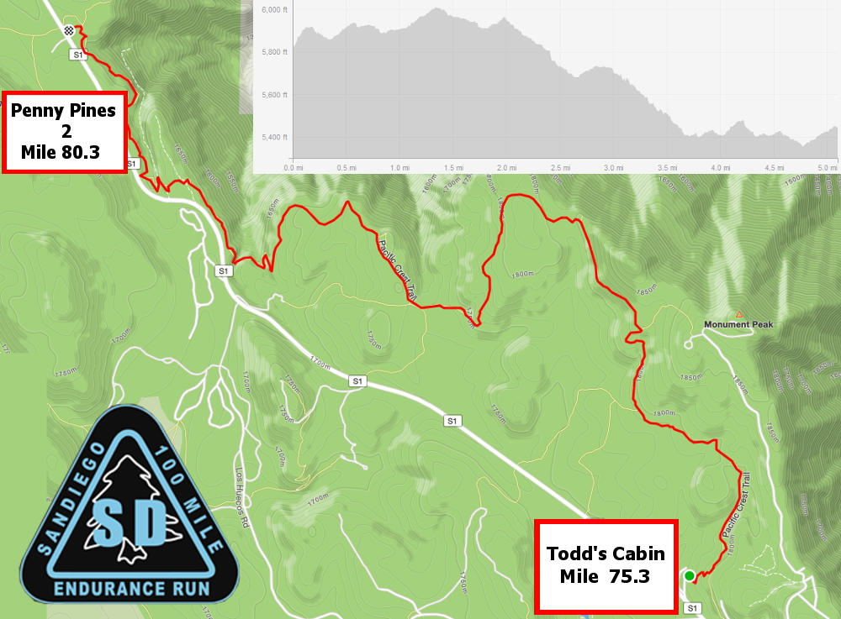

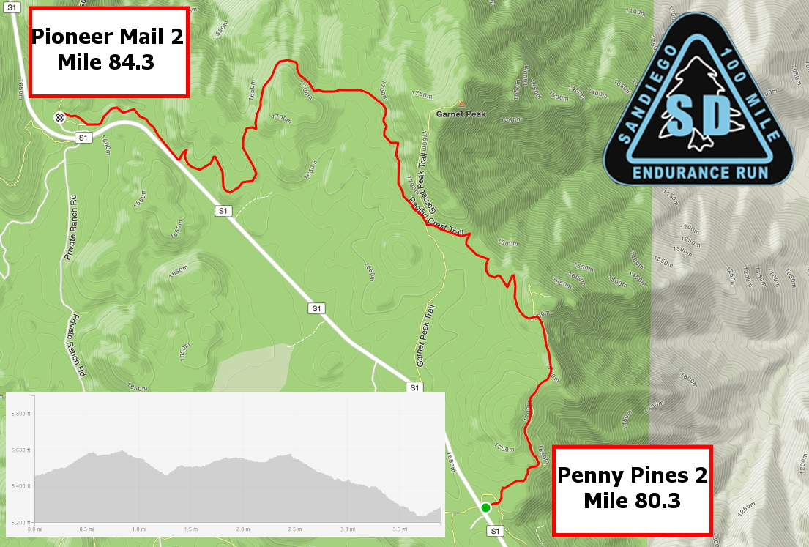

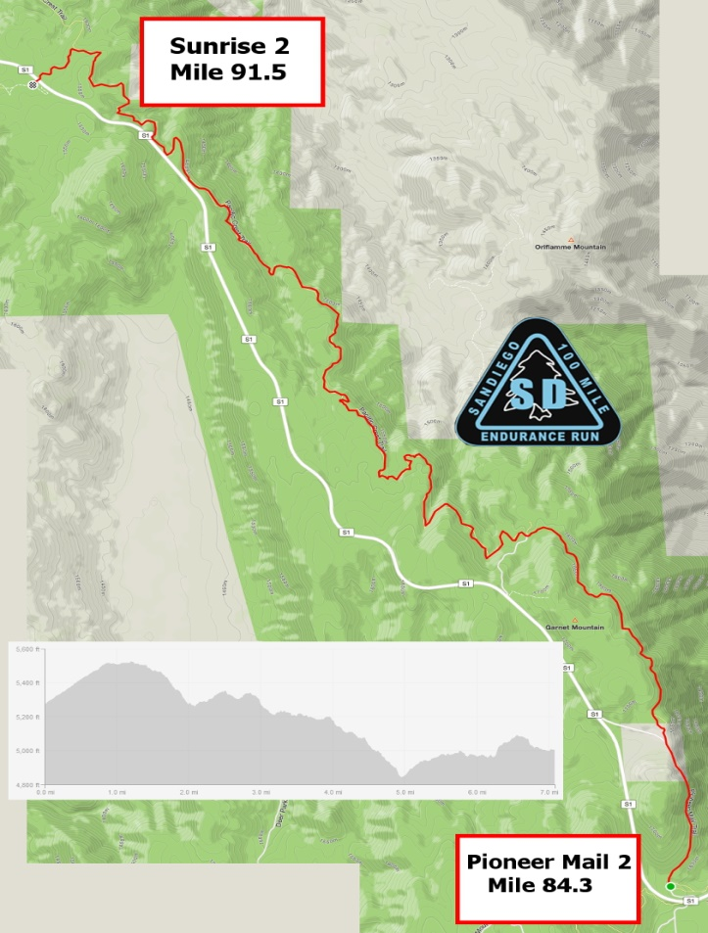

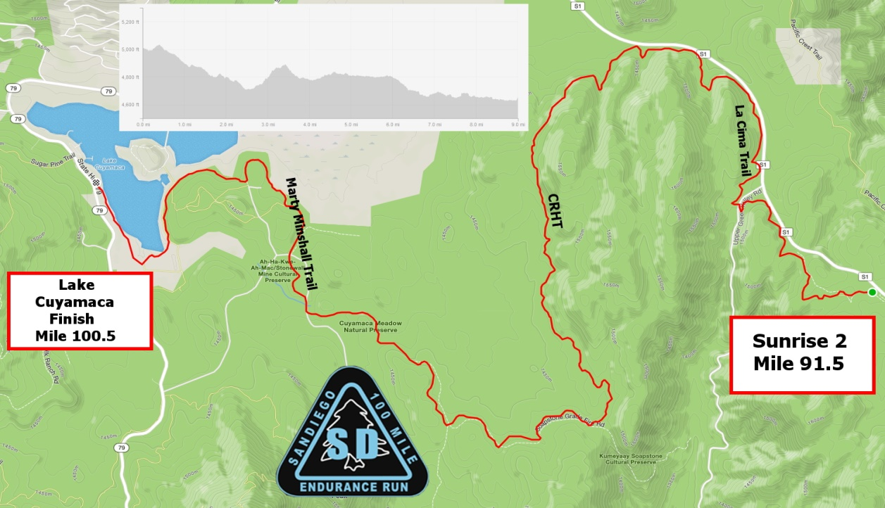

***Turn by Turn Directions: Start to Penny Pines 1:***

***Turn by Turn Directions: Penny Pines 1 to Sunrise 2:***



***Turn by Turn Sunrise 2 to Finish***



***Drop Bags***

1. Runners may have drop bags (clearly marked with runner's name, bib #, and applicable aid station) for personal needs at the designated drop bag aid stations (eg, Sunrise 1/2, Pioneer Mail 1/2, Penny Pines 1/2, Red Tailed Roost and Cibbet’s Flat).
2. Drop bags are restricted in size to the equivalent of of a large shoe box (16 x 12 x 6- this size will be strictly enforced). All bags need to be durable, water proof, and secure.
3. Your drop bags must be placed in the applicable aid station containers at the start area (Lake Cuyamaca) no later than 5:15 am race morning. These drop bags bins should be sorted by aid station and number, so make sure you are putting the bags in the right bin that matches your race number. Any bags that exceed the size limitations will not be accepted or transported.
4. **For those aid stations that are transited twice (Pioneer Mail 1&2, Sunrise 1&2, and Penny Pines 1&2) use only one drop bag for both passes**.
5. Drop bags will be returned to Lake Cuyamaca approximately an hour after the applicable aid station closes. **Unclaimed drop bags will not be mailed back to entrants, so PLEASE pick up your drop bags prior to leaving the venue.** Unclaimed drop bag clothing and gear will be donated to charity.
6. If you decide to withdraw, or finish the race prior to the drop bags being returned to Lake Cuyamaca, you or your crew can drive to the applicable aid station if it is still open and claim the bag that way.

***Pacer Rules***

1. Pacers may accompany their runner for safety and companionship, not to lighten the load or run ahead of their runner to get supplies in advance of an aid station arrival. Pacers must check in and out of each aid station along with their runner so course monitors know they are on the course.
2. Pacers are entitled to use all the aid and resources at aid stations but are not allowed to carry (mule) or physically assist their runner.
3. Pacers are allowed to accompany a runner (one pacer at a time) beginning at Red Tailed Roost. If a runner leaves Meadows aid station AFTER 8:00 pm, the runner is allowed to have their pacer start at that location since it will be dark before they arrive at Red Tailed Roost.
4. Pacers are required to wear the applicable Pacer Bib. When a pacer switches off to another pacer, the bib must be transferred to the subsequent pacer.
5. Pacers may switch at Cibbets Flat (mile 64), Penny Pines 2 (mile 80.3), Pioneer Mail 2 (mile 84.3), and Sunrise 2 (mile 915). Penny Pines 2 is not a crew accessible aid stations; however, pacers can be dropped off or picked up at this aid station. Cibbets Flat has very restricted parking. Crew and/or pacers must park on Fred Canyon Rd. and walk the 1/3 mile to the aid station. NO EXCEPTIONS. Our permit relies on not having unauthorized cars in the Cibbets Flat Campground. The aid station director has been specifically authorized to disqualify any runner whose crew/pacer drives into the campground.
6. Runners may have multiple pacers (family and friends) accompany them the last mile of the race. Those who would like to run the last mile (or less) to the finish line, may hike out from the finish to meet their runner, and can then run in with them to celebrate the finish.

***Crew Information***

* 1. Crews must have an SD 100 parking pass to access crew accessible aid stations. These will not be distributed with the race packet. These will be distributed to the crews directly at the start finish line at 1 of two times:
     1. Immediately following the runners briefing, approximately 6:15 PM on Thursday, June 2.
     2. Immediately following the start, approximately 6:05 AM on Friday, June 3.

If your crew cannot pick up their parking pass at one of these 2 times, they MUST contact the race directors to arrange their parking pass. Anyone found to be crewing without a parking pass will result in an immediate disqualification for their runner. We hate to be jerks about this, but crew and spectator parking and interaction with the public and aid station personnel is the number one threat to the permit of the race, and crews are the number one violator of race, forest service and state park rules, so we want to ensure that there can be no question about what the rules are and what is expected of you as crews. It will still be lots of “fun”, promise! We just want to make sure we are all on the same page as it is critical to the race’s continued existence.

* 1. Crews are allowed to meet runners at the following designated aid stations: Lake Cuyamaca (start), Sunrise 1, Pioneer Mail 1, Meadows, Red Tailed Roost, Cibbets Flat (with restrictions – see below), Pioneer Mail 2, Sunrise 2, and the finish line
  2. Crews may drop off a pacer at Penny Pines 2 but cannot meet or support their runner at that location due to limited parking.
  3. Cibbets Flat has very restricted parking. Crew and/or pacers must park on Fred Canyon Rd. and walk the 1/3 mile to the aid station. NO EXCEPTIONS. Our permit relies on not having unauthorized cars in the Cibbets Flat Campground. The aid station director has been specifically authorized to disqualify any runner whose crew/pacer drives into the campground.
  4. Crews who stop to meet their runner at other than crew access aid stations jeopardize time penalties or disqualification of their runner.
  5. Crews must obey all parking restrictions and are required to have an Adventure Pass and an SD 100 parking pass displayed in their vehicle windshield for parking in the Cleveland National Forest. Cleveland National Forest aid stations are: Pioneer Mail 1/2, Red Tailed Roost, Cibbet’s Flat, and Meadows. Day Adventure Passes can be purchased in Pine Valley at the Market, at the Mt Laguna General Store, or Mt Laguna Visitor Center for $5.00.

**Crews Accessible Aid Stations:**

1. **Sunrise 1** (mile 21): Park diagonally on Sunrise Hwy (S-1) or in the parking lot as directed. You can carpool from Sunrise Aid Station and leave your car there.
2. **Pioneer Mail 1** (mile 28.2): Park on Sunrise Hwy or as directed in the parking lot. Park facing the direction of traffic. Make sure all tires are behind the white lines of the road.
3. **Meadows** (mile 48.8): Park on both sides of Sunrise Hwy facing direction of traffic.
4. **Red Tailed Roost** (mile 55): Park on both sides of Sunrise Hwy or as directed in the parking lot if room is available.
5. **Cibbet’s Flat Campground** (mile 64): Entering and parking in the Campground is not authorized. You may park on Fred Canyon Rd to drop off or wait for your runner’s pacer or walk to the aid station which is approximately a third of a mile from Kitchen Creek Rd to the aid station )(campsite #9). Crews and Pacers should follow the ribbons on foot to the aid station where there will be a designated area for pacers to wait for their runner.
6. **Penny Pines 2** (mile 80.3): **This is a pacer drop off aid station only due to limited parking.** You may drop off or pick up a pacer but cannot crew or meet your runner here.
7. **Pioneer Mail 2** (mile 84.3): Park along Sunrise Hwy facing the direction of traffic or in the parking lot as directed if space permits.
8. **Sunrise 2** (mile 91.5): Park diagonally on the side of Sunrise Hwy or in the parking lot as directed if space permits.
9. **Start and Finish Line at Lake Cuyamaca:** Turn into the north parking lot of Cuyamaca Lake or park on Hwy 79 but abide by the No Parking sections along some sections of Hwy 79. **Do not park in front of the Lake Cuyamaca Restaurant – FOR CUSTOMERS ONY!**

***Crew Driving Directions***

* 1. **Lake Cuyamaca to Sunrise 1**: Head northeast on Hwy 79 towards Julian for 3 miles, turn right on Sunrise Hwy (S-1) and head south 3 miles to Sunrise 1 Aid Station located at S-1 green mile marker #34.5. Park as directed. This is about 8 minutes driving time.
  2. **Sunrise 1 to Pioneer Mail 1:** Head south on S-1 for 5 miles to S-1 green mile marker 29.5. Park on either side of Sunrise Hwy in the direction of traffic flow. This is about 8 minutes driving time.
  3. **Pioneer Mail 2 to Meadows:** Head south on S-1 for 10.5 miles to S-1 green mile marker 19.5. The drive time to Meadows is about 20 minutes. Park on either side of Sunrise Hwy in direction of traffic flow.
  4. **Meadows to Red Tailed Roost:** Drive back north on S-1 Hwy for 3.5 miles to Red Tailed Roost which is located at green mile marker 22.5. Park on side of S-1 or in parking lot as directed. This is about 8 minutes driving time.
  5. **Red Tailed Roost to Cibbet’s Flat Campground:** From Red Tailed Roost drive south on S-1 for 10 miles until you come to Interstate I-8 and enter the freeway heading east towards El Centro. Drive 7 miles to exit #54 (Kitchen Creek Rd) and turn left to head north towards Cameron Station and Cibbet’s Flat Campground. It is 4.7 miles to the entrance of the Campground. You must park on Kitchen Creek Rd and not enter the Campground. You must walk a third mile through the Campground to the aid station (follow the signs and ribbons). This is about a 30 minute drive and an hour drive to the start/finish, so think carefully if you want to crew there. There is absolutely no cell service at Cibbet’s Flat. There is a pacer tent for pacers to await their runner. **CREWS ARE NOT ALLOWED drive access into the AID STATION or your runner will be penalized!**
  6. **Cibbet’s Flat to Penny Pines 2 (PACER DROPOFF ONLY):**  Retrace your directions back to Sunrise Hwy (drive back south on Kitchen Creek Road for 4.7 miles, enter Interstate I-8 heading west and exit at Sunrise Hwy (exit #47) to head back north on S-1. Penny Pines 2 is also a pacer drop off only aid station and is unauthorized for crews to meet their runner. There is again pacer tent for the pacer to await the runner. Penny Pines is located at S-1 green mile marker #27.5. It is about 35 minutes to drive from Cibbet’s Flat to Penny Pines 2.
  7. **Penny Pines 2 to Pioneer Mail 2:** Continue north on S-1 Hwy another 2 miles to Pioneer Mail 2 Aid Station which is located at S-1 green mile marker 29.5. Park on the side of S-1 or the Pioneer Mail parking lot as directed. This is 5 minutes driving time.
  8. **Pioneer Mail 2 to Sunrise 2:** Drive further north on S-1 Hwy for 5 miles to S-1 green mile marker #34.5 to Sunrise Aid Station. This is about 8 minutes driving time.
  9. **Sunrise 2 to Lake Cuyamaca Finsh Line:** Continue north on S-1 Hwy for 3 miles to Hwy 79, turn left onto Hwy 79 towards Lake Cuyamaca for 3 miles. Just past the Lake Cuyamaca Restaurant, turn left into the north parking lot….use Hwy 79 for over flow parking if needed. It is about 8 minutes driving time from Sunrise back to the Lake.

**CAUTION: Sunrise Highway is extremely dangerous as motorcycles and cars speed excessively. There have been wildlife strikes at races in the past. Be very careful and stay alert when entering and exiting parking lots and your car.**

*Awards*

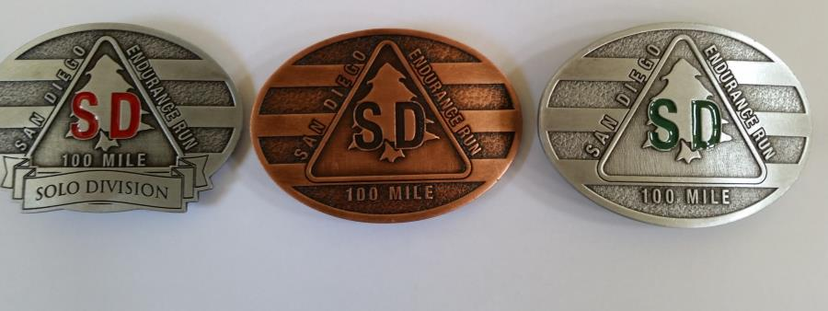

**Buckles:**

* Finishers will receive their Finisher Buckle and Finisher’s Medallion upon crossing the finish line.

There are 3 distinctive buckles: **Sub-24 Hour Finisher**, **Solo Finisher**, and **Finisher** (finishing between 24 hours and 32 hours.

**Other Awards:**

In addition, awards will be given to individuals for the following:

* 1st, 2nd, & 3rd Male Overall
* 1st, 2nd, & 3rd Female Overall
* 1st, Solo Male
* 1st, Solo Female
* 1st Male Master (40+)
* 1st Female Master (40+)

All finishers also receive the coveted SD 100 Embroidered Hoodie, and other excellent swag. We think you’ll enjoy the goodies earned to show off that you actually did this thing!

*Frequently Asked Questions (FAQ’s)*

**Q: How do I volunteer for the event?**

**A:** Volunteers are the life blood of the event and we therefore appreciate any offers to help. We have tasks that include course marking, sweeping, aid station helpers, registration, timing, post-race food preparation, clean up and logistics roving. If you would like to help, please contact us prior to May 1 at: Sandiego100rd@gmail.com to coordinate task assignments that work for you and the event. Thanks for volunteering.

**Q: Why do you have a website, Facebook Page and Twitter account for the event?**

**A:** The race web site contains all the information you should need to properly prepare for the event. PLEASE take the time to thoroughly review the Participants Guide on the web site and copy applicable documents for you and your crews/pacers/supporters. Facebook and Twitter are used to communicate with other runners to share information like training runs, make requests for pacers, share transportation, coordinate lodging opportunities, etc.

**Q: Will there be a live webcast for the race?**

**A:** Yes, we will use www.ultralive.net to post runner's times as they pass major aid stations. These times will be delayed some due to poor transmission from remote aid stations and internet connectivity limitations. The link for the live cast will be located on the web site homepage: [www.sandiego100.com](http://www.sandiego100.com/).

**Q: Are the packet pick up and formal race briefing mandatory?**

**A:** The formal pre-race briefing is mandatory for runners who have not run the San Diego 100 before. It is HIGHLY encouraged for all runners. If you are unable to attend this briefing, you must sign in and process for the race NO LATER THAN 5:00 am on race morning. **All runners** will be required to check in at race start, just so we know who is on course.

**Q: Are the mandatory cutoff times at aid stations strictly enforced?**

A: Yes, the runner must leave the aid station at or before the mandatory cutoff time. This is non-negotiable. Failure to abide by this rule will result in disqualification and will result in the runner being banned from all future San Diego Ultra Slam events.

**Q: What type of food and drink will be available at aid stations?**

A: Aid stations will have as a minimum, water, electrolyte drink (Tailwind Nutrition), gels, coke, mountain dew, ginger ale, ice, electrolyte pills, fruit, salty food (eg chips, pretzels), cookies, sandwiches (PB&J), and some candies. Night time aid stations will have hot soup and hot drinks. All of the aid stations will have at least 1 vegan option. If you have special needs for your diet (eg gluten free, etc), please use your drop bags for your specific replenishment needs. Aspirin, motrin, advil or other medicants are not provided at any aid stations.

**Q: What is the average temperature for SD 100?**

**A:** The SD 100 course covers elevations of 3,000' up to 6,000' and parallels high ridges along the PCT. Typically for this time of year, the average temperature range is from the low 40's to the mid 80's. However, due to the low humidity, exposure on some sections, and the ever-possible strong winds, be prepared for near freezing wind chill factors at night and extremely hot day time heat indexes. It is not unusual to find temperatures in the high 90s on race day, so be prepared.

**Q: Will there be any formal training runs on the course?**

**A:** There will be at least four and possibly five training runs prior to the race. Here are the details (but see the website front page or emails from us with possible updates).

Each of the runs will be between 20 and 25 miles as outlined below. We will have an aid station at some point along the run which we will mark with orange ribbon in case you miss the bright orange jugs or gallons of water. These aid stations will have water and perhaps Tailwind and gels for you at a minimum. We are very grateful to Tailwind for stepping up to not only sponsor the race but these training runs as well. There will be a small fiesta at the end of each of the runs where we will provide light snacks including adult beverages. Please bring a chair and hang out with us to enjoy the rest of the day.

Each of the runs will start at 7 AM (with one exception noted below) with a little briefing by the RD's about key turns and what to expect for your day. When the runs finish, of course, is up to you. There may be some minimal marking at important turns, but we will expect you to know the course and be able to navigate without ribbons on the course. We will be present to answer any questions before you get started.

Training Run 1 – See website/email for date

Big Bend to Sunrise - We will trace the first 21 miles of the course. We will meet at Big Bend (mile 1.1 of the course), which is a wide turnout with an information board, just past mile marker 10.5 as Highway 79 makes a big bend to the right. If you are coming from the South (I-8), it is just before Lake Cuyamaca. If you are coming from the north (Julian), it is just after Lake Cuyamaca. We will follow the course over Middle Peak, down through Paso Picacho where there is water, over Stonewall Peak, down past Chambers, and then through the meadows and back along Sunrise Highway to the Sunrise Aid Station.  There is limited parking at the start, so we recommend parking at Sunrise and carpooling to the start if possible. There is no parking on Highway 79, but there is some overflow parking on the Scout road. We will help find you a spot to park if necessary. There will be light refreshments and an adult beverage or 2 for you at the finish.

Training Run 2 - See website/email for date

Pioneer to Pioneer - We will run from Pioneer Mail up and over Champagne Pass, dropping to Pine Creek road (BOO PAVEMENT) and then up Noble Canyon, the Crux of the Race and then back along the PCT to Pioneer Mail. This combines the section from Pioneer Mail to Penny Pines 1 and crossing Highway 79 to Penny Pines 2 to Pioneer Mail, which comes later in the course. This allows us to have a loop and preview 2 portions of the race, if not necessarily in sequential order. We will have aid available at the bottom of Noble Canyon, which is known as Hammer’s Hideaway after long time captain Steve “Hammer” Cunningham who passed after the 2019 race. Pour a little tailwind out for a great guy when you go through during the race. His sister and widow will be heading up the station in his honor this year. When you finish, look for some kind of festivities at Pioneer Mail for finishing what many believe to be the hardest section of the race!

Training Run 3 – See website/email for date

Red Tail to Red Tail – You will get to cruise through the meadows of Mt. Laguna with aid at Penny Pines during today's 21 mile run. The run will begin with a run down Thing Valley Road where, at the location of Dale’s Kitchen, we will turn left on the PCT and travel north for 8.5 miles to Penny Pines 2 which would be miles 71.7 to 80.3 of the race.  At that point, we will CAREFULLY cross the highway where aid will await at the site of Penny Pines 1 and travel on miles 43.8 to 55 of the course, from Penny back to Red Tail Roost where a picnic sponsored by SURF will be waiting with sandwiches, beverages and a general festive atmosphere.

Training Run 4 - Saturday May 7

Red Tail Roost to Dale's Kitchen to Sunrise - We're a month out. Are you ready? Come find out as we run 21.3 miles from Red Tail Roost on Sunrise Highway over to Dale's Kitchen where we join the PCT north back to Sunrise. We'll probably place some aid at Penny Pines 2 at 10.1 miles. This section has some of the best views on the course out over the desert, views which many of you faster folks may miss if you are running this section in the dark. This rolling section is a ton of fun on fresh legs. Not so much on 80 mile legs. For those who did Training Runs 2 and 3, there will be some overlap; however, it is important to run this leg as a single push to get a feel for what you may be in for late in the race. Again, we will have refreshments at the finish for you.

Training Run 5 NIGHT RUN - See website/email for date

By popular demand, this run has become official. Led by Greg Bergeron in the past, this 13ish mile run will start at 7 PM, not 7 AM, as we traverse the dreaded out and back to Cibbett’s Flat from Red Tail Roost. As many if not all of you will run some part of this in the dark, what better way to practice? There will be aid at the halfway mark, before you climb back up the PCT in the dark back to Red Tail Roost. We will have extra marking for this run but prepare to be spooked! Any rumors of a haunted clown hiding in the rocks of Long’s Creek are highly exaggerated. OR ARE THEY???

**Q: Can I have more than one pacer at a time?**

**A:** No, only one pacer is allowed to accompany their runner at a time. Pacers are only allowed to switch out at crewed aid stations (except Penny Pines 2). The first location a pacer can join his or her runner is at Red Tailed Roost (mile 55) unless a runner leaves Meadows Aid Station after 8:00 pm since it would then be dark before that runner reached Red Tailed Roost. Pacers can switch out at Cibbets Flat (drop pacer only, no crew access), Penny Pines 2 (drop pacer only, no crew access to aid station due to limited parking), Pioneer Mail 2, and Sunrise 2. There is cell reception at Penny Pines 2 so a crew is able to coordinate with a pacer who has a cell phone with them. There is no cell reception at Pioneer Mail parking but there is signal less than a mile north on Sunrise Hwy at Kwaaymii Point turn off.

**Q: Can I meet my runner at other than crew access aid stations?**

**A:** No, crews are strictly limited to meeting their runner at crew access aid stations only. Failure to abide by this rule jeopardizes disqualification of the crew's runner. Each runner (non SOLO Division) will be given one Crew/Pacer car windshield pass to allow that one vehicle to park at Crew Access checkpoints. Cars that do not have this pass are unauthorized to park and must carpool with someone who does have a pass. Sunrise 1 and Sunrise 2 have ample parking to park and then carpool.

**Q: Are there showers at the finish line?**

**A:** No. You can drive around the Lake one mile to the Lake Cuyamaca Chambers Campground, and there are two coined operated showers next to the RV sites that have hot water. The cost is 25 cents per 2.5 minutes of shower. Bring some quarters.

**Q: Is there a formal Awards Ceremony?**

**A:** No, all finishers will receive their finisher's medallion, belt buckle, embroidered finisher's hoodie, and other goodies shortly after crossing the finish line. However, we highly encourage finishers, crews, pacers, and family to stick around at the finish line and enjoy watching others finish. There will be food and refreshments available until the last runner finishes.

**Q: If I have to withdraw from the event, can I transfer my entry or roll it over to the following year?**

**A:** Given the current situation with COVID, we are trying to be as flexible and fair in our refund policy. Please see the website for the latest policy for obtaining a partial refund in the months leading up to the race. Unfortunately, at some point, all the awards, swag, venue costs, permit fees, etc are obligated; as such, we can’t provide a refund. No rollovers except for pregnancy related reasons. Sorry.

**Q: Are trekking poles and music headphones allowed on the course?**

A: Trekking Poles are allowed to be used but do not have them out the first mile of the course due early crowding on narrow sections when runners have not yet spread out. Headphones are allowed but we request you keep the volume low or only use one earbud to allow you to be safe. Night time headphones are highly discouraged for obvious reasons.

**Q: Will there be aspirin, ibuprofin, motrin or any other pain relievers at aid stations?**

**A:** No, Aid stations will not have any of the above pain relievers available to runners. If you carry your own, please be responsible and follow recommended dosages on the bottle. Ibuprofin can be very diuretic and affect your kidneys during strenuous endurance events, so be sure to drink lots of fluids throughout the event to minimize any potential issues with dehydration.

**Q: If I am competing in the Solo Division, can any spectators of mine meet me at aid stations just to watch and cheer?**

**A:** One of the main reasons for the Solo Division is to reduce the number of support and pacer vehicles at crew accessible aid stations. As such, Solo Runners will not be given a Crew/Pacer parking pass: hence, spectators will only be allowed to see their runner at the Start and Finish line if their runner is a Solo competitor.

**Q: What are the local times for sunrise and sunset, and what is the moon phase for race weekend?**

**A:** Sunrise is about 5:40 AM. Sunset is about 7:55 PM.

***Useful Information Links***

[Ultralive.Net](http://www.sandiego100.com/sponsorOpen.asp?intLoc=page&URL=www.ultralive.net.&iAID=44)

[**http://www.ultralive.net**](http://www.ultralive.net)

1. San Diego 100 will provide race day online live tracking of all runners. We use the **Ultralive** platform to record and display each runner’s progress throughout the race. Please recognize that due to remote locations along the course (with limited reception), input times may be delayed.



**http://**[**www.sdtrailfit.org**](http://www.sdtrailfit.org)

1. The **San Diego Trailfit** Program headed by Ken Bonus provides the management and leadership to maintain and oversee most all of the trails for the SD 100 as well as other trail runs in the east county mountains of San Diego. We hope and encourage all local San Diego area participants accomplish their volunteer service requisite by signing up online for SDTrailfit.



[**http://www.sandiego100.com/sanDiegoUltraSlam.asp**](http://www.sandiego100.com/sanDiegoUltraSlam.asp)

1. The **San Diego Ultra Slam** is composed of four San Diego ultra- marathons.  To be eligible for the award, participants must complete each race in the calendar order they occur.  However, you may choose whichever race you wish to start with.  Each race offers a different distance and distinct challenge to the participant, and running all four within one year represents a significant achievement.  Your accomplishment will be memorialized on this site, and your award will be presented to you at the conclusion of your final race.
2. Online SD 100 **Merchandise Sales** is located at:

[**http://squareup.com/market/sd100-merchandise**](http://squareup.com/market/sd100-merchandise)

1. Weather Link for Julian, CA:

[**https://weather.com/weather/tenday/l/USCA0530:1:US**](https://weather.com/weather/tenday/l/USCA0530:1:US)