

***Table of Contents:***

* **Overview ……………………………………………………………… 2**
* **Race Location / Directions ……………………………………. 3**
* **Registration / Qualification / Lottery / Refunds ……. 4-6**
* **Solo Division Info …………………………………………………. 7-8**
* **Lodging ………………………………………………………………… 8-9**
* **Schedule of Events ………………………………………………. 10-11**
* **Race Rules …………………………………………………………… 12-14**
* **Course Information ……………………………………………… 15-16**
* **Aid Station Chart …………………………………………………. 17**
* **Overall Course Map …………………………………………….. 18**
* **Overall Course Profile ………………………………………… 19**
* **Segment Leg Maps with Elevation Profiles ..……….. 20-25**
* **Turn by Turn Directions ………………………………………. 26-28**
* **Drop Bags …………………………………………………………… 29**
* **Pacer Information/Rules …………………………………….. 30**
* **Crew Information/Directions ……………….……………… 31-35**
* **Awards ………………………………………………………………… 36**
* **Frequently Asked Questions (FAQ’s) *……………………* 37-41**
* **Sponsors …………………………………………………………….. 42**
* **Useful Information Links: ……………………………………. 43-45**



***Overview***

***Welcome***

On behalf of the Race Directors, Volunteers, and Sponsors, welcome to the Annual San Diego 100 Mile Endurance Run (SD 100). The SD 100 was founded by Paul Schmidt in 2001 and has grown in popularity with entrants coming from across the US and numerous international countries.

The event maintains a 300 runner limit with qualification standards required to apply for entry. A lottery may be required to select the starting field due to higher demand than permits allow. A waitlist is maintained once the 300 entrant limit is reached.

Registration information and everything you need to know about the event is contained in this Runner Handbook and the race website at [www.sandiego100.com](http://www.sandiego100.com).

We’re committed to do our best to help prepare you to successfully run a tough and challenging 100 miles in the beauty of the San Diego east county mountains. We look forward to another great race in the east county mountains of San Diego.

***Race Location/Directions***

The San Diego 100 starts and finishes at Lake Cuyamaca located 9 miles south of Julian, CA. The south parking lot of Lake Cuyamaca serves as the race venue for packet pickup, check-in and the pre-race briefing. Lake Cuyamaca is located at: 15027 Highway 79, Julian, CA 92036. **Directions Link: goo.gl/QGr4JH**

***Registration / Qualification***

**Cancellation Policy:** If for any reason the event is cancelled due to an act of nature or other Forest Service permit issues, the race director will make every effort to refund all unobligated funds to entrants or roll over entry fees to a rescheduled race date. Entrants must accept the fact that there are risks involved in staging an ultra in the wilderness and there are no guarantees that all entry fees will be refunded if the run is not held as advertised.

**Qualification to Apply:** To apply for the race each year, applicants must have completed an official 50 mile race within a 13-hour time limit. A 100K or a 100 mile race within the race finishing time also serves as an acceptable qualification. You have until April 1, 2023 to achieve your qualification. The results of the qualification must be verifiable on Ultrasignup or annotated on an official web site of the race used for qualification.

As a requisite for participation, entrants are required to volunteer 6-hours towards trail maintenance, or volunteer work at any running or community service event. This requirement must be completed and certified to the Race Director by mail or email to sandiego100rd@gmail.com once the service is completed.

A list of completed volunteer service completions is maintained and updated weekly.

In lieu of completing trailwork (or in addition!), a runner may donate $100 to support SURF, trailwork, and our volunteers. A donation to San Diego Ultra Friends (SURF) goes to support Trailfit, our local trail maintenance organization, to ensure that the trails in our mountains are well maintained. Ken Bonus and his crew do a fantastic job, and a SURF donation goes to ensure that they have the resources they need, including equipment and training.



We hope and encourage the greater San Diego area SD 100 participants to complete their volunteer service in the east county San Diego trails we use for the 100 miler. Information about the San Diego Trailfit program and how to sign up for a workday are located at <https://www.sdtrailfit.org> .

**Registration Application:**

Applicants have a four-day entry period to apply. Once applications are closed, if necessary, a lottery is conducted to select the 300 runner entrant field. Lottery results are posted within a few days after the lottery. Entrants will be notified of their selection. Non-selectees will then have to opportunity to sign up on the wait list immediately following the official posted entrant’s list on Ultrasignup. Should a lottery not be necessary, a waitlist will be maintained once the 300 runner entrant field is filled.

**C:\Users\scottemills\Documents\2018 San Diego 100\Ultrasignup Logo 2.png**

**Entry Fee / Refunds:**Entry to SD 100 is $325 plus the Ultra Signup fee (approximately $20). If an entrant withdraws from the event and notifies the race director prior to April 15, they are entitled to a receive a 50% refund minus the Ultrasignup fees. No refunds after April 15. No rollovers or transfer of entries once an applicant is a confirmed entrant unless a runner becomes pregnant for which we will gladly roll over an entry into the following year.

***Solo Division***

1. Entrants declare their intent to enter the Solo Division (S) when they register. Anyone can change to Solo or Supported (NS) before May 30 by notifying the RDs. After that time, there will be no changes, and a Solo runner must run Solo.
2. Solo Division runners are not allowed to have crew or pacers assist them throughout the race. They rely solely upon the official aid stations and their drop bags.
3. Solo Runners are not allowed to have spectators at any aid station other than the start and finish, and as such, will not be given a pacer bib or crew vehicle placard at check-in.
4. Solo Runners are allowed to run with other runners and/or their pacers but cannot rely on them (other than in an emergency) for support.
5. If entrants violate the Solo Division Rules, they are not disqualified from the race but will no longer be recognized as a Solo Division finisher.
6. All Solo Runners will wear a wristband to distinguish them in the Solo category. Solo runners will not receive a crew pass or pacer bib at check in since they have no access to either.
7. Runners may not change to supported during the race.

SOLO finishers will be awarded special award the SOLO FINISHER Belt Buckle for their accomplishment of tackling the 100 mile course unassisted.

***Lodging / Camping / RV’s***

Lake Cuyamaca, Cuyamaca Rancho State Park, and Julian, CA are very popular vacation destinations in early and mid-June. Make your reservations early in your planning or you may have difficulty finding lodging for race weekend.

Lake Cuyamaca has rental facilities for campsites and RV's. Several of the cabins and condos are already reserved to accommodate weekend volunteers; however, there are a few available if you reserve early. Reservations and deposits are for staying at Lake Cuyamaca: [**www.lakecuyamaca.org**](http://www.lakecuyamaca.org).Or you can call at 760-765-0700 for reservations. Be sure to let them know you are with San Diego 100.

There are several lodging options available in the nearby town of Julian which is only 9 miles from the start. The **Julian Chamber of Commerce website** has many possibilities: [**http://www.visitjulian.com**](http://www.visitjulian.com).

**Cuyamaca Rancho State Park (Paso Picacho Campground)** is only 3 miles from Lake Cuyamaca and has campsites and cabins to rent:[**http://www.reserveamerica.com**](http://www.reserveamerica.com)

Also check out **Mt Laguna Lodge** for accommodations in the Mt Laguna Recreational Area section of the race (about 18 miles from Lake Cuyamaca but near many of the middle aid station locations): [**www.lagunamountain.com**](http://www.lagunamountain.com)

Another popular option is the Ayres lodge in Alpine, which is approximately 30 minutes from the start. [**Official Site | Ayres Lodge Alpine (ayreshotels.com)**](https://www.ayreshotels.com/ayres-lodge-alpine)

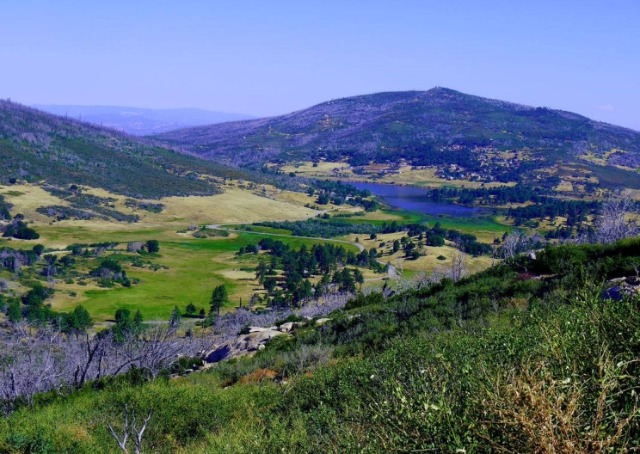

***Schedule of Events for 2023***

**Thursday, June 1, 2023**

* 3:00 pm to 5:30 pm: Optional pre-race check-in and bib pick up at Lake Cuyamaca south parking lot.

Please note that there is no in-person briefing. **However, there is a mandatory video briefing with a link on our website.** **WATCHING THIS BRIEFING VIDEO IS MANDATORY.** There will be a secret password somewhere in the video, and you will need that password to pick up your bib.

One of the RDs will be onsite to answer your questions if you have any. There also will be several other volunteers who are valuable sources of information.

**Friday, June 2, 2023**

* 4:30 am - Check in and bib pick up to get last minute details, pick up your bib, and deposit drop bags. ARRIVE EARLY - PARKING IS EXTREMELY TIGHT! The later you arrive the further you will have to walk to get to the start. There is no parking along Hwy 79 so if you arrive late, you will have to walk upwards of a half mile from an available and legal parking location. If you are just dropping off a runner, you will not be allowed to enter the lot, but you can drop your runner off at the entrance to the parking lot for a short walk to the start.

You must check in, even if you got your bib the day before! We need to know who is on the course for your safety. **REMEMBER, YOU MUST KNOW THE SECRET WORD FROM THE BRIEFING VIDEO TO GET YOUR BIB.**

* 5:15 am: All Drop Bags must be deposited at appropriate aid station bin next to the Registration Tent. Drop bags that do not meet the 16 x 12 x 6 size limitations will not be accepted. Drop Bags will be organized by number and aid station, so please pay attention where you leave your Drop Bag. Drop Bags should be labeled with runner number and aid station. Drop Bags leave venue at 5:30 am! Drop bags will not be under cover, so they may get wet. It is unlikely in June, but plan accordingly.
* 5:50 am: Final Race Briefing in front of Start Banner.
* 6:00 am: Race Start in front of Registration Tent. We will not allow any runners to start late since sweep runners will be removing marking ribbons just behind the last runner/s.

**Saturday, June 3, 2023**

* 12:00 am to 6:00 am: Sub-24 hour finishers arrive at finish line and receive their **SUB-24** hour buckles.
* 6:00 am to 2:00 pm: Sub 32-hour finishers receive their **FINISHER** buckles.
* 6 AM. Beginning of food service and party at finish line.
* Solo Runners who finish under 32 hours receive **SOLO** buckle.
* Light food and refreshments will be served beginning midnight Friday with more hearty fare beginning at 6 AM until the event ends. Runners will receive a free meal and drinks, but food and drinks will be available for purchase for everyone. We encourage everyone to relax, have fun, and enjoy seeing the runners achieve their dreams.

**SATURDAY, JUNE 10, 2023**

**Post Race Fiesta!** – This will be at Hopnonymous Brewery from 1 – 4 PM. <https://goo.gl/maps/difHaiK5aMKAXTpe8>

First beer is on us if you wear your official SD 100 swag. We encourage you to buy your volunteers a beer as many of them will be there with you to share stories and good times.

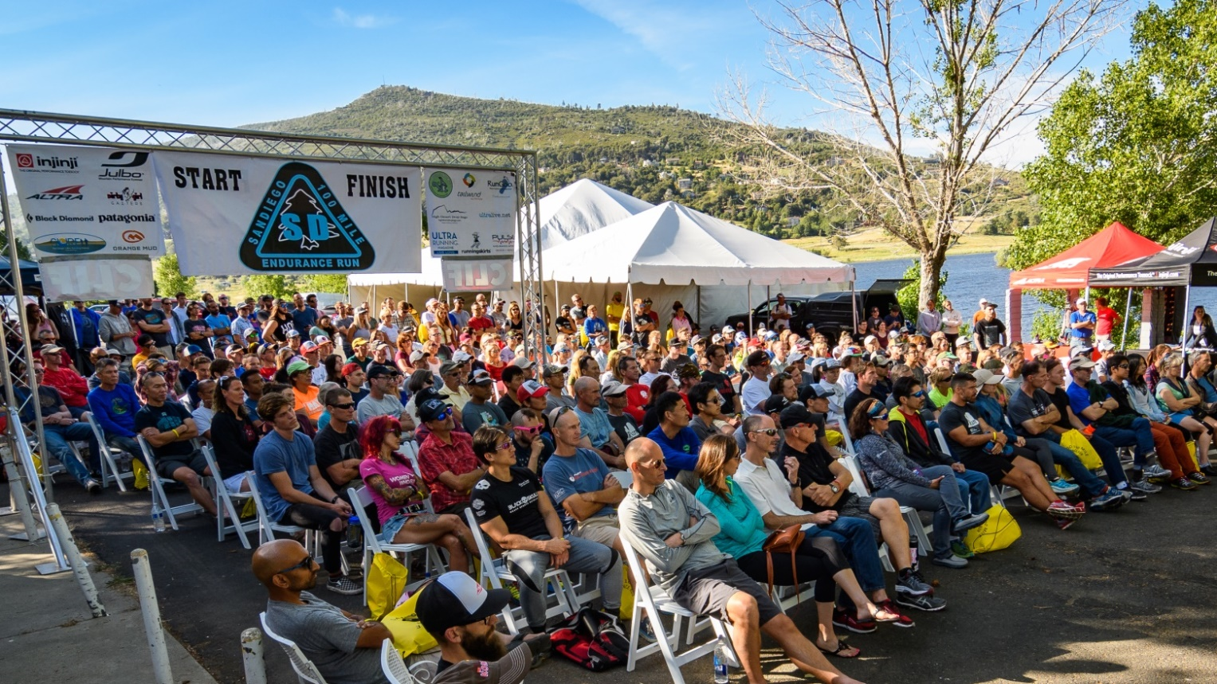

***Race Rules***

**Getting Lost, Cutting the Course, and Cut Off Times**

1. SD 100 is a “Closed Course” You must follow the official course or you are not an official finisher.
2. If any runner gets lost or cuts the course, they’re required to return to the point at which they went off course by their own means and continue the run from that point. If a runner does not return to that point or continues on after cutting a section of the course, they are disqualified.
3. Runners who do not make the mandatory cut off times as written on the Course Information Chart are also DQ'd. The Aid Station Captain exercises the authority of the Race Directors. They have the authority to pull a runner from the race if they feel it is unsafe for the runner to continue. Please do not argue with the aid station captain's decisions. If an Aid Station Captain determines that it is unsafe for you to continue, you must surrender your race bib. Arguing with the Aid Station Captain may result in the runner not being allowed to participate in any future San Diego 100 or San Diego Slam race.
4. **Dropping out of the race:** If a runner drops from the race for any reason, it is the runner's sole responsibility to personally notify the nearest aid station captain that he or she is withdrawing from the race. **The runner is also required to physically remove and give their race bib to the aid station captain**. Failure to notify an aid station that you are out of the race and failure to turn in your bib # may result in costly search and rescue measures which will be the responsibility of the runner.
5. **YOU CANNOT DROP AT LYLE’S WATER BREAK OR ZUNIGA’S KITCHEN.** You must proceed on foot to the next aid station to drop. This is especially important to consider as you leave Cibbet’s Flat as it is 11 miles with quite a bit of climbing before you have a way out. **DO NOT LEAVE CIBBET’S UNLESS YOU FEEL 100 PERCENT SURE YOU CAN TRAVEL 11 UPHILL MILES.**
6. Failure to abide with any of the rules or decisions of the aid station captain will result in you not being allowed to participate in any future SD 100 or San Diego Slam race.

**Littering**

Dropping litter anywhere on the course is strictly prohibited. Carry all trash to the next aid station and dispose of it in the appropriate receptacles.

If you happen to see a gel pack or other race related litter that was accidentally dropped, please pick it up for us and dispose at next aid station. Thank you for keeping our trails litter free!

**Relieving Yourself**

If you must relieve yourself, get off trail and out of sight. Bury and cover solid waste and toilet paper properly. LEAVE NO TRACE! There are bathrooms or porta-potties at Lake Cuyamaca, Paso Picacho, Chambers, Sunrise 1/2, Pioneer Mail 1/2, Red Tailed Roost, Cibbets Flat and Meadows.

**Medical Issues**

You are responsible for your own safety. We have a medical director and will have medical care volunteers during the run. We have trained several people at our expense in CPR and wilderness first aid to try to ensure your safety. But they are not located at every aid station. Ultimately, YOU ARE RESPONSIBLE FOR YOUR OWN HEALTH AND SAFETY. In case of an emergency, we will endeavor to get local emergency personnel to an injured runner (or vice versa) as soon as possible, but due to the remoteness of the course, this could take hours. This is an event with risks. Please thoroughly read the registration waiver and recognize it is up to you to make wise decisions with regards to health and safety.

The race has liability insurance only. This insurance covers litigation over negligent acts and does not cover medical costs incurred by the runner. If you do not have medical insurance, we recommend you join USATF. This race is sanctioned and insured by USATF and members may be able to be reimbursed for medical costs (with a cap of about $6k) if the medical condition was not due to negligence on the part of the runner. For more information, check out USATF’s on line web site.

**Pets**

For liability insurance purposes and permits, dogs are not allowed at aid stations or on the course. Dogs will be allowed in a very restricted area in the shade away from the runners at the start finish venue. This rule will be **strictly** enforced. Dogs are also not allowed on California State Park trails. It is the runner's responsibility to brief and inform your crew and/or spectators of this restriction. This has in the past resulted in penalties for the runners.

Beyond all this, it is likely going to be hot during the race, and you will be endangering your fuzzy friend by bringing him or her to the race as a car is not a great place for a dog during the summer. Do your dog and runner a favor and leave the pups at home.

**Smoking**

Please no smoking at aid stations or the start finish venue.

***Course Information***

* The SD 100 course covers 5 major areas: Lake Cuyamaca, Rancho Cuyamaca State Park, Mt Laguna Recreational Area, Pacific Crest Trail (PCT), and the Noble Canyon and Indian Creek Trails.
* The trails are under the jurisdiction of the US Forest Service Descanso District (75%), the California Rancho Cuyamaca State Park (20%), and the Lake Cuyamaca Recreational Area (5%).
* The course is approximately 80% single track trails, 17% forest service roads and 3% asphalt road. There are some technical and rocky sections (mostly in Noble Canyon). The PCT sections total about 42 miles of the course. The overall elevation climb and descent are approximately 13,000 feet each.
* Runners should be totally familiar with those sections that are bi-directional (course travels one direction outbound and then the opposite direction inbound). Pay very close attention to applicable course markings and review the overall course map so as to have the big picture of the course. There have been instances of course marking vandalism in past races. As such, we recommend carrying a copy of the course maps and/or detailed route directions for sections that you are unfamiliar with. Moreover, there are course videos which show all major turns on the course (and some not-so major). Do yourself a favor and check these out along with the maps and turn by turn directions. You will stand a much better chance of finishing or meeting your goals if you take these simple preparations.

[(10) Cliffs and Meadows - YouTube](https://www.youtube.com/c/Cliffsandmeadows)

***Aid Station Chart***

|  |  |  |  |  |  |  |
| --- | --- | --- | --- | --- | --- | --- |
| Aid Station | Leg | Total | Drop Bags | Crew | Pacer Change | Cut Off |
| Paso Picacho | $$7.5$$ | $$7.5$$ | No | $$No$$ | $$No$$ | 8:30 AM |
| Chambers | $$5$$ | $$12.5$$ | No | $$No$$ | $$No$$ | 10:45 AM |
| Sunrise 1 | $$8.5$$ | $$21$$ | Yes | $$Yes$$ | $$No$$ | 12:30 PM |
| Pioneer Mail 1 | $$7.2$$ | $$28.2$$ | Yes | $$Yes$$ | $$No$$ | 3 PM |
| Hammer’s Hideaway | $$8$$ | $$36.2$$ | No | $$No$$ | $$No$$ | 5:15 PM |
| Lyle’s Water Break* | 5 | 41.2 | No | No | No | None |
| Penny Pines 1 | $$2.6$$ | $$43.8$$ | Yes | $$No$$ | $$No$$ | 8 PM |
| Meadows | $$5$$ | $$48.8$$ | No | $$Yes$$ | $$After 8 PM$$ | 9:30 PM |
| Red Tail Roost | $$6.2$$ | $$55$$ | Yes | $$Yes$$ | $$Yes$$ | 11:15 PM |
| Cibbets Flat** | $$9$$ | $$64$$ | Yes | $$Yes$$ | $$Yes$$ | 2:00 AM |
| Zuniga’s Kitchen* | $$7.7$$ | $$71.7$$ | No | $$No$$ | $$No$$ | None |
| Todd’s Cabin | $$3.6$$ | $$75.3$$ | No | $$No$$ | $$No$$ | 6:00 AM |
| Penny Pines 2*** | $$5$$ | $$80.3$$ | Yes | $$Yes$$ | $$Yes$$ | 7:15 AM |
| Pioneer Mail 2 | 4 | 84.3 | Yes | Yes | Yes | 8:30 AM |
| Sunrise 2 | 7.2 | 91.5 | Yes | Yes | Yes | 11:15 AM |
| Finish | 9 | 100.5 | Yes | No | Yes | 2:00 PM |

* There is no dropping at either Lyle’s or Zuniga’s. Runners must proceed on foot to the next aid station to drop. Lyle’s is a **water only** station.

** Crews and Pacers must park on Kitchen Creek Road and walk ½ mile QUIETLY through Cibbets Flat Campground to aid station.

***Pacer must be dropped off to wait for runner and cars must leave immediately after drop off. Cars can return only once new pacer has arrived. Please ensure your pacer has a cell phone to contact the pick up vehicle or arrange a time accordingly.

***Shuttle Schedule***

There will be a shuttle to pick up dropped runners and return them to the start/finish line; however, in most cases, it will not be scheduled to come to the aid station until after the station closes. It will make unscheduled stops as time allows. As such, if you have a crew, and you drop at a crew accessible station, this will be a much better option for you. If your crew gives you a ride out, you will likely be asked to take another dropped runner with you. We appreciate in advance your willingness to help out your fellow runners!

Shuttle Schedule:

Hammer’s Hideaway: 5:30 PM

Penny Pines 1: 8:15 PM

Meadows: 9:45 PM

Red Tail Roost: 11:30 PM

Cibbets: 2:30 AM

Todd’s Cabin: 6:15 AM

Penny Pines 2: 7:45 AM

Pioneer Mail 2: 9:15 AM

***Overall Course Map***

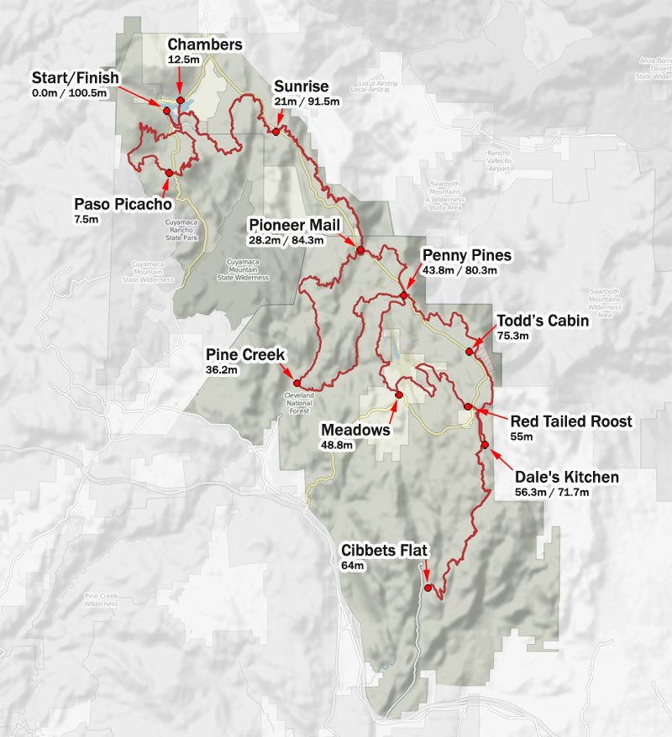

***Aid Station with Profile Elevation***

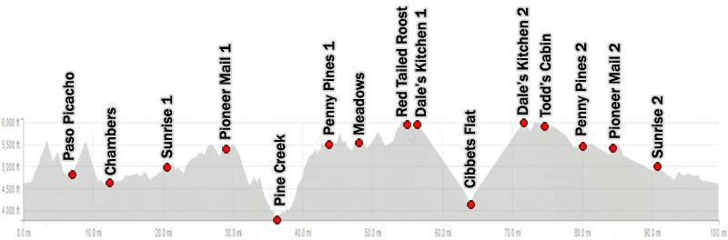

***Segment Leg Maps with Elevation Profiles***

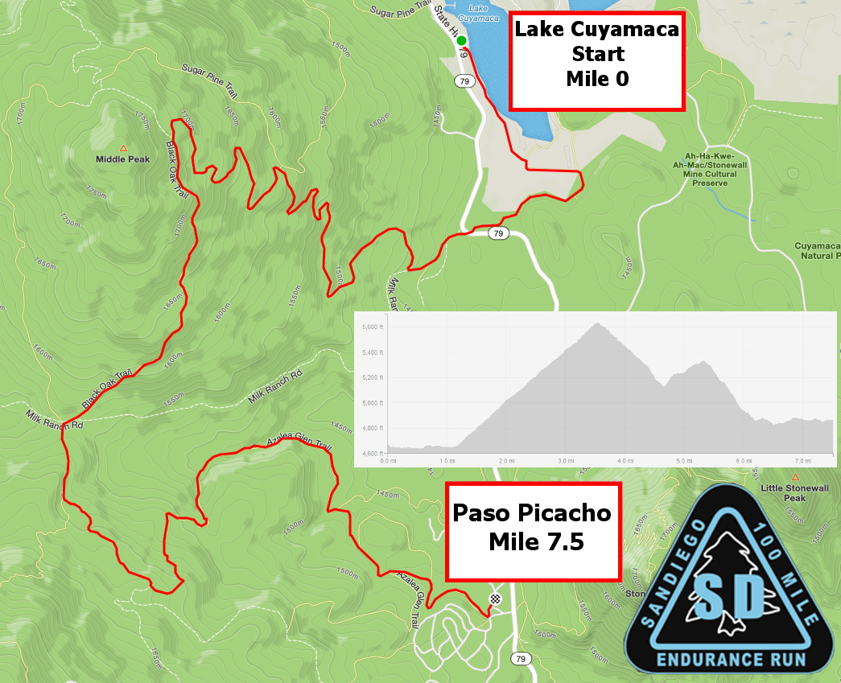

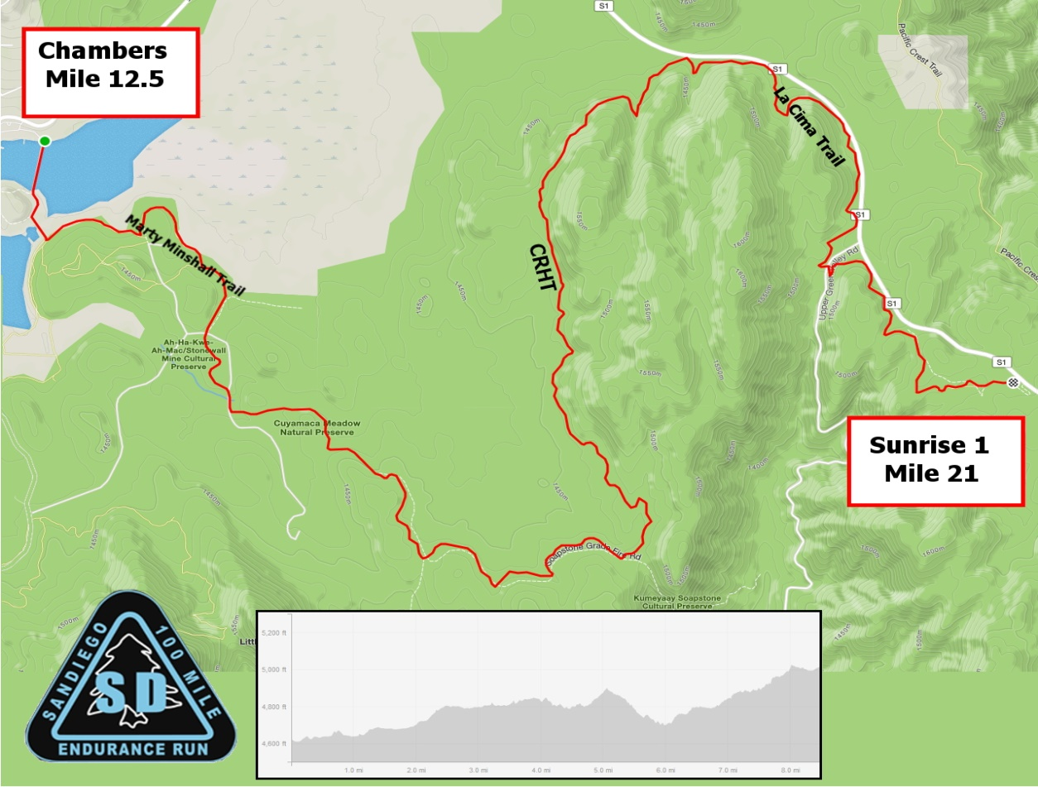

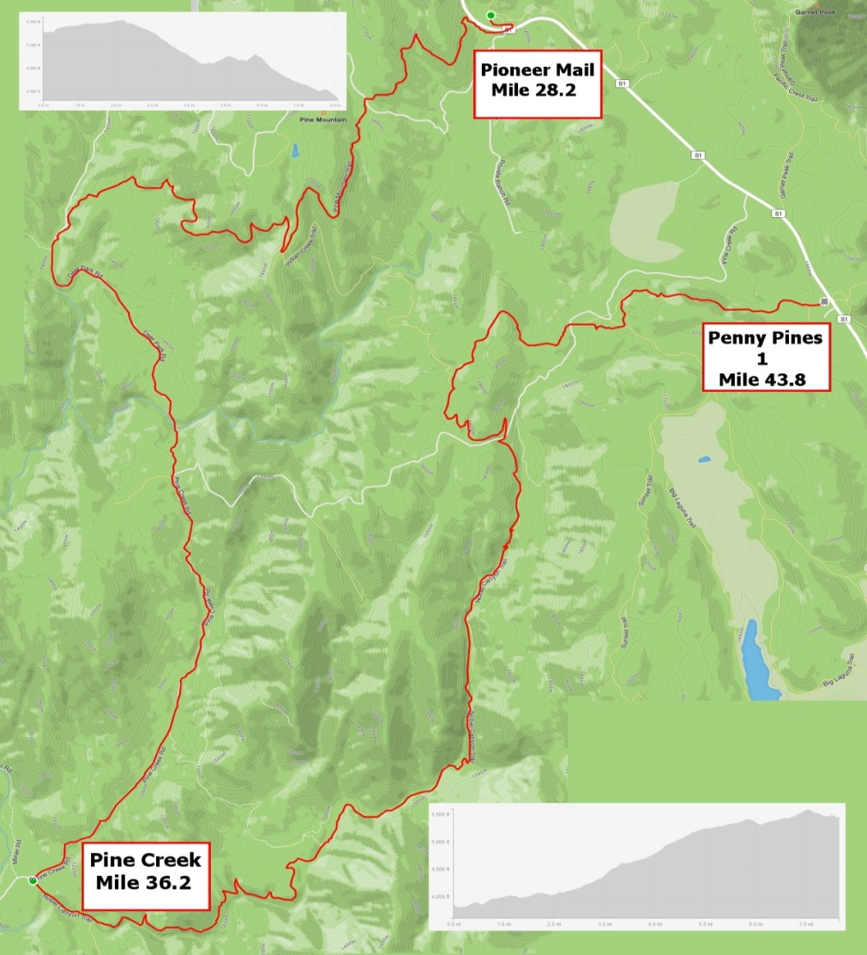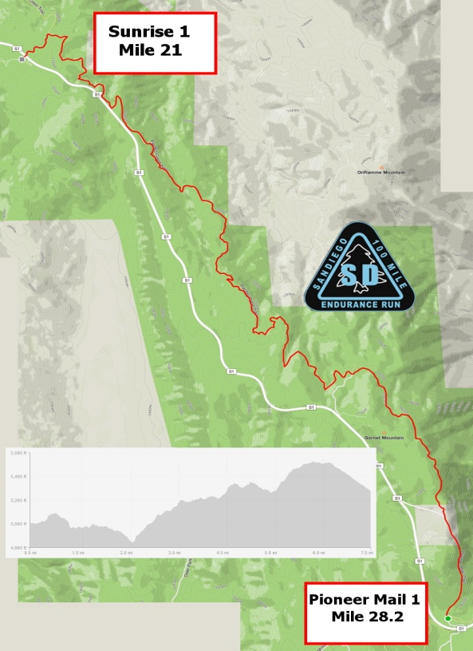

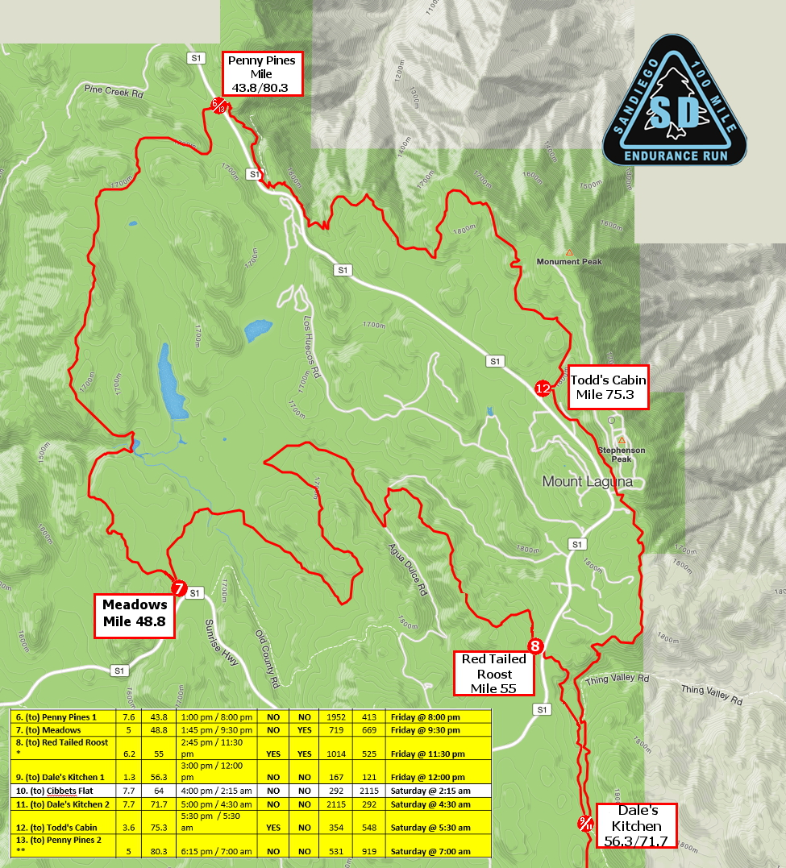

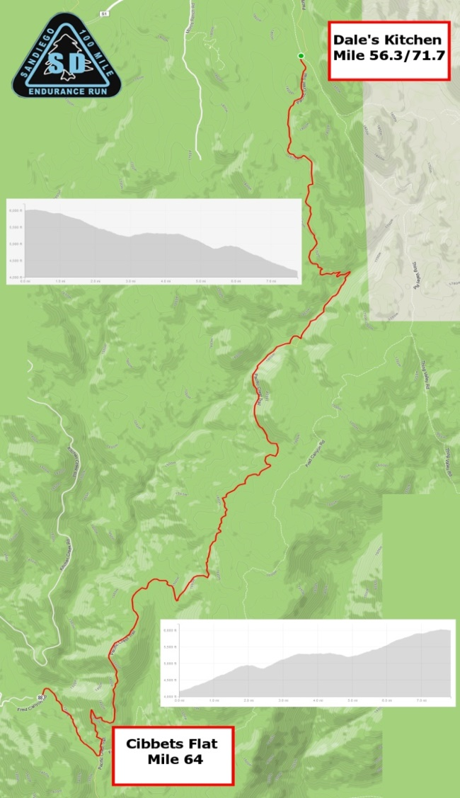 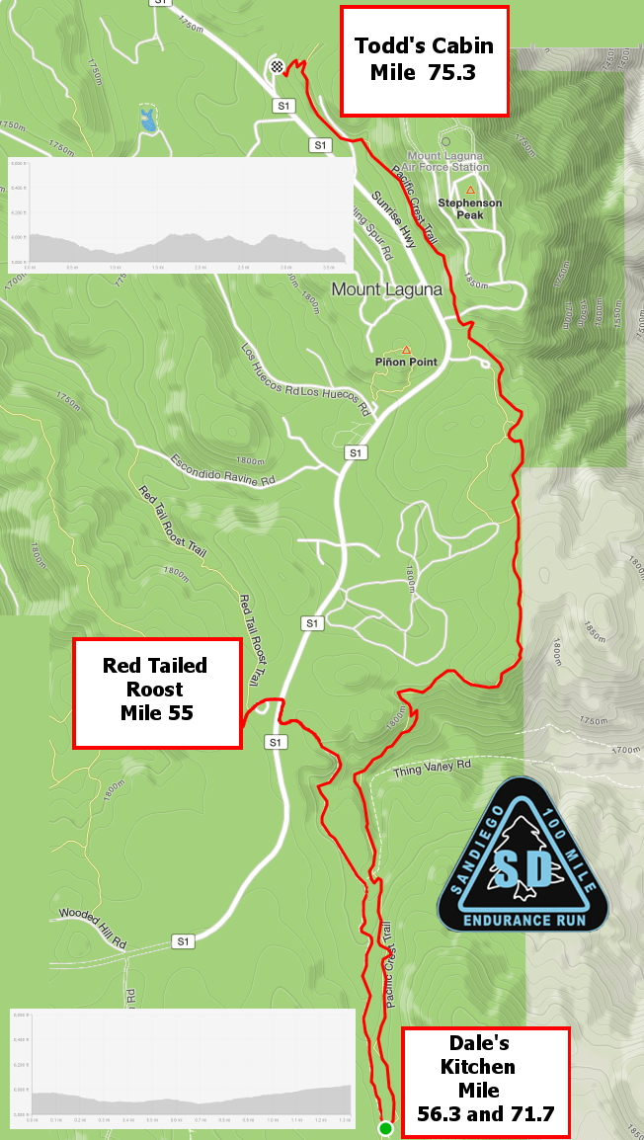

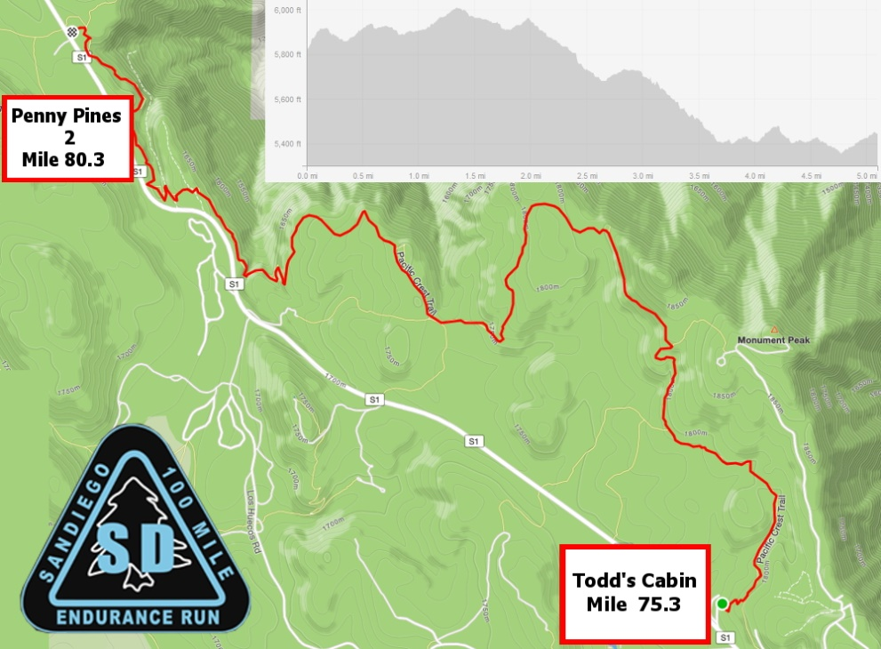

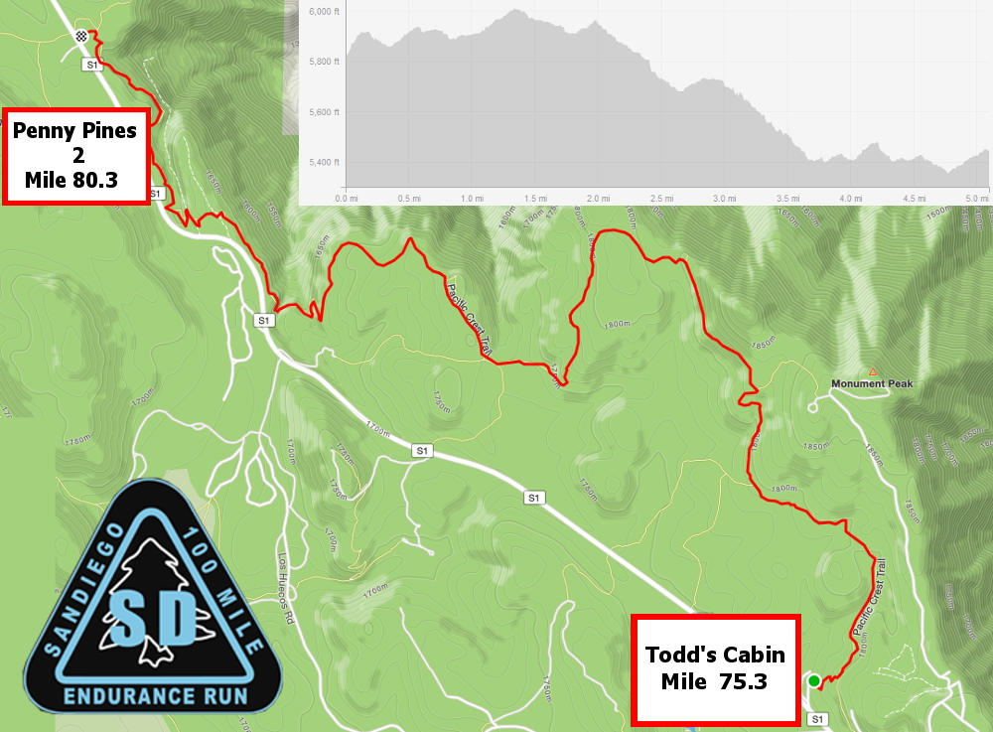

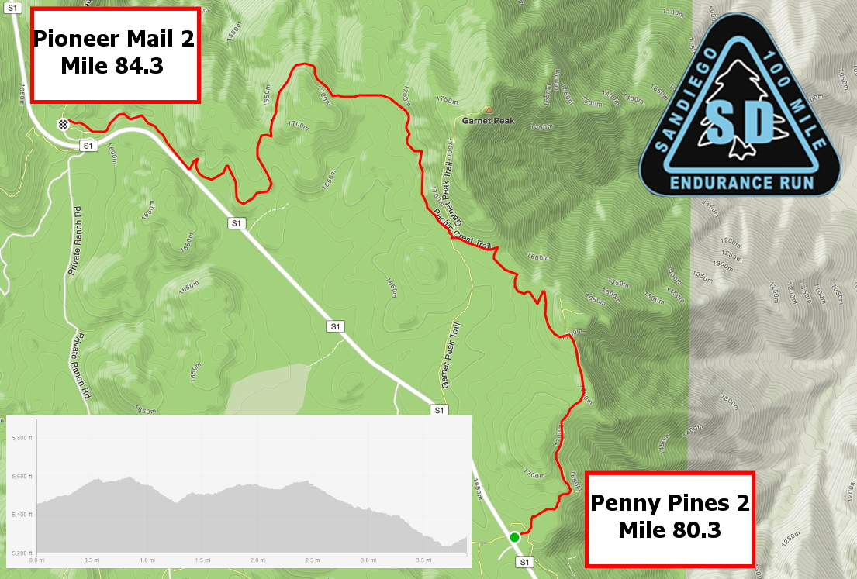

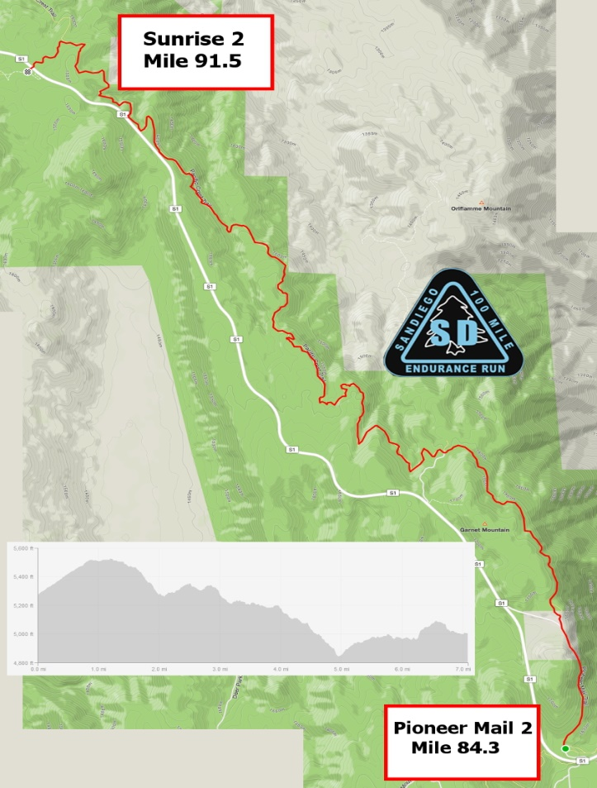

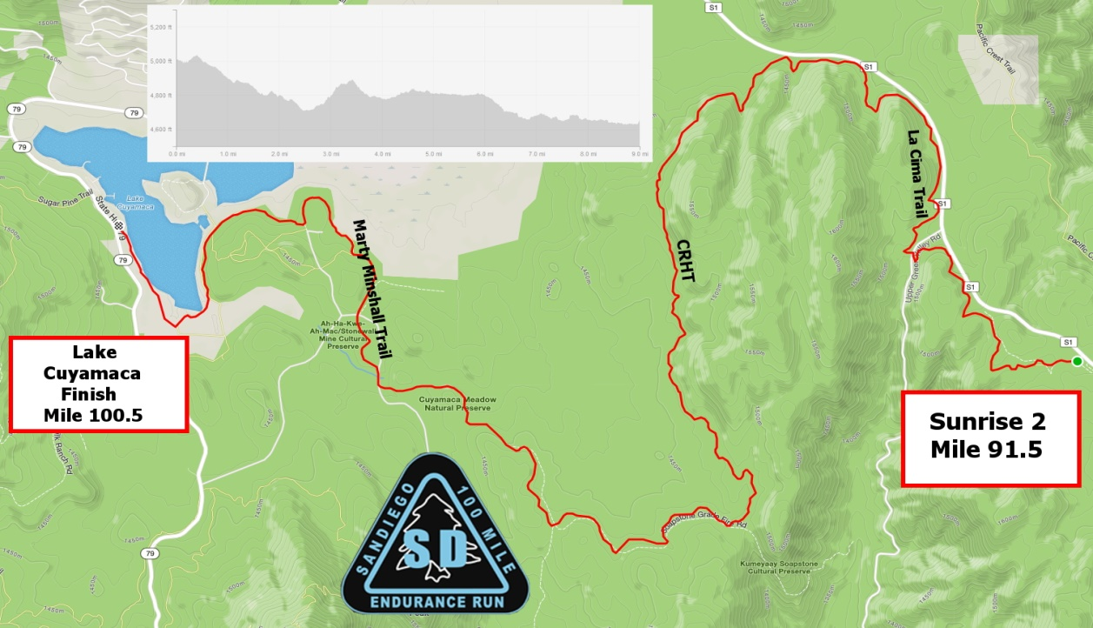

***Turn by Turn Directions: Start to Penny Pines 1:***

***Turn by Turn Directions: Penny Pines 1 to Sunrise 2:***



***Turn by Turn Sunrise 2 to Finish***



***Walk Through Description***

Start to Paso Picacho (7.5 miles)

The race begins with a nice mile run on tight single track through a meadow around the lake. NO PASSING HERE. You can pass once you cross highway 79 and get to a climb up a fire road. After climbing a few miles at a steady grade, there is some single track downhill to a 4 way intersection (watch the ribbons) and then rolling fire road to a rocky, technical downhill to Paso Picacho where The Running Skirts will be ready to greet you with crazy energy and usually crazy costumes.

Paso Picacho to Chambers (5 miles)

Your second climb of the day takes you almost to the top of Stonewall Peak at a gentle grade with some technical downhill after the top down to a meadow and around a wooded peninsula and across a dam to Chambers. Once you are back by the lake, pay attention to look for the left hand turn to cross the dam to Chambers. This is a short out and back to the aid station, but worth it to visit Dave and Juliet York at the Tiki Bar.

Chambers to Sunrise 1 (8.5 miles)

It will start to warm up as you sadly leave the mai tais behind, but your spirits will rise as you leave the lake and head out onto a fire road through some beautiful meadows. You then make a left hand turn onto some single track after 3.5 miles for some of the most beautiful running you’ll find in Southern California. You will stay on the single track all the way until you visit Joey and his crew at Sunrise who have been working that station since before most of you knew how to tie your running shoes!

Sunrise 1 to Pioneer Mail 1 (7.2 miles)

Many people call this their favorite part of the run with the entire section other than the first .2 miles on the PCT with unbelievable views over the Anza Borrego desert. The running is rolling, but technical, so don’t get too lost in the views where you forget to watch your step! After you cross a paved road, you will have about a mile of very runnable downhill to Pioneer Mail 1 where Gloria King will be waiting to take care of your every need and get you cooled off for your next big push.

Pioneer Mail 1 to Hammer’s Hideaway (8 miles)

You will cross busy Sunrise Highway again to begin a slow single track grind up to Champagne Pass, about 2.5 miles where you will make a right down a beautiful, single track descent to Pine Creek Road. You will make a left where the single track T’s into the fire road. Do not go straight here! The dirt road rolls until a sharp, short climb at which point you merge with a paved road (about 1.5 miles) and run that for a little over 2 miles downhill to Hammer’s Hideaway.

Hammer’s is named after a long time volunteer who captained this station for years and passed suddenly a few years ago. It is expertly captained by his friend Mixter, who love carrying forward his legacy, and members of his family will be there helping out. As they help cool you down, pour a little tailwind out in Hammer’s memory. Or have a beer, as that would be much more in his spirit.

Hammer’s Hideaway to Penny Pines 1 (7.6 miles)

Fill up all your bottles (at least 3) for this next section, which most believe to be the crux of the race. It is a long hot climb through Noble Canyon. If you are lucky, there will be some pools you can dip your hat in. It begins rolling but as you get into the trees, the climbing starts in earnest. You get a brief respite after crossing a paved road 5 miles in where Norb and Lori Lyle have brought their good love all the way from Arizona and will be waiting to refill a bottle for the remaining 2.6 miles to Penny. There will only be enough water to fill 1 bottle for the last 2.6 miles, and THERE IS NO DROPPING HERE, so plan accordingly as you have to hike it out to Penny Pines 1 to drop. Once at Penny, Dax and Sanam who have worked Penny 1 for years will take amazing care of you and get you back in the race.

Penny Pines 1 to Meadows (5 miles)

A beautiful section of meadows, the trail becomes rolling, giving you a break after the long grind of Noble Canyon. Navigation here can be tricky, so please be sure to review your GPX, maps, turn by turn directions, etc. You will get some amazing views of Stonewall Peak back to the west, giving you an idea of just how far you’ve come! Once you make it to Meadows, Angela’s husband Mike will have some excellent BBQ and other goodies to get you ready for the evening. You can have a pacer here beginning at 8 PM.

Meadows to Red Tail Roost (6.2 miles)

The trail continues to roll, giving you time to recover, as for many of you night starts to come. The course takes you back into the meadows (watch out for cows!) then into the forest, ending with a steep climb with lots of false summits before dropping down to visit Noble Canyon 50k RD Steve Ling at the Red Tail Roost. Once you leave the Roost, it is difficult to get you back to the start/finish line until you get to Todd’s Cabin, 20 miles later, and may include waits of hours to get a ride, so it is an excellent point to re-evaluate whether today wasn’t your day.

Red Tail Roost to Cibbet’s Flat (9 miles)

A 1.3 mile section of fire road brings you back to the PCT where you will take a right, and you will drop 7.7 miles to the Cibbets Flat aid station. You will be back at this junction in a little over 15 miles! Those in the mid pack or later may see an aid station being set up at the turn off of the fire road to the PCT. Ignore it for now. It will be waiting for you 15 miles later. This will be night time for most of you, and there isn’t much tree cover, so take 10 seconds to stop and look at the stars and contemplate how far you’ve come (but not how far you have left!). Its also an excellent opportunity to encourage all the runners on this out and back section that are climbing up towards you. Make sure you don’t miss the right hand turn after about 7 miles on the PCT (8.5 total from Red Tail) onto fire road down to Cibbet’s Flat aid station where Jeff Hooker, President of SURF, and his family and friends are waiting to take care of you.

Cibbet’s Flat to Zuniga Kitchen (7.7 miles)

When you leave Cibbet’s flat, it is over 11 miles until you can drop, and the first 7.7 is climbing back up to where you just came from, so you have to feel pretty good (relatively speaking) to leave here. If it is close to the cut off, you likely will not make the next cut barring a miraculous recovery. Really take the time and use some self-truth before you leave the station. Once you gird your loins, climb up, up, up from whence you just came. The number 1 missed turn on the course is turning back on the PCT after the half mile climb from the aid station back up to the PCT. It will be marked with a festival of lights and ribbons, but folks miss it anyways, and feel really dumb later when they come back and see how well it is marked. ***DO NOT MISS THIS LEFT TURN BACK ONTO THE PCT.*** After a total of 7.7 miles, you will hit the Zuniga Kitchen, where brothers Matt and Randy will be waiting with some tough love and hot soup. It is a remote aid station with a full aid station only 3.6 miles away, so get a boost and then get moving! YOU CANNOT DROP HERE AND MUST PROCEED ON FOOT TO TODD’S CABIN.

Zuniga Kitchen to Todd’s Cabin (3.6 miles)

The major climbs are over, and its time for some rolling, runnable (if anything is runnable after 70 miles) but technical trail with some amazing views in the moonlight and probably some gusty winds until you take a left off the PCT for a short jaunt downhill to Todd’s cabin, where Todd (yes it is his cabin) and Carolla and friends will be waiting for you with first class hospitality.

Todd’s Cabin to Penny Pines 2 (5 miles)

The trail rolls for a bit with a decent climb (OK, the climbing isn’t entirely over) before a downward trend to Penny Pines 2. Just across the street from where you were at mile 43.8 after your Noble Canyon adventure, temperatures will be quite a bit cooler, and Tracy DiMino and her squad will be waiting to get you all you need for the final push home.

Penny Pines 2 to Pioneer Mail 2 (4 miles)

More fantastic single track in a relatively short rolling push to the next station where Gloria is still there (WHAT?) with her amazing group of volunteers ready to push you towards a glorious finish.

Pioneer Mail 2 to Sunrise 2 (7.2 miles)

You’ve done this section before, but now in reverse, so all that uphill you were cursing on the way out is now your friend. We are guessing it will seem a lot longer this time for most of you, and the trail rolls in and out of side canyons, so stay patient! For those in the mid to back of the pack, it will be getting hot again, so be sure to have lots of ice and water before heading out. Joey and his folks will be waiting to get you all you need for a glorious finish!

Sunrise 2 to Finish (9 miles)

This is it! The glory ride home. Lots of rolling trail with great meadow views followed by a jaunt around the lake and a dash for the finish. You’ll see and hear the finish line about a mile or so before you get there, so stay patient and soak it all in! You can have as many friends and family run in with you from a mile out to the finish, so make it a party and congratulations!!!

***Drop Bags***

1. Runners may have drop bags (clearly marked with runner's name, bib #, and applicable aid station) for personal needs at the designated drop bag aid stations (eg, Sunrise 1/2, Pioneer Mail 1/2, Penny Pines 1/2, Red Tailed Roost and Cibbet’s Flat).
2. Drop bags are restricted in size to the equivalent of of a large shoe box (16 x 12 x 6- this size will be strictly enforced). All bags need to be durable, water proof, and secure.
3. Your drop bags must be placed in the applicable aid station containers at the start area (Lake Cuyamaca) no later than 5:15 am race morning. These drop bags bins should be sorted by aid station and number, so make sure you are putting the bags in the right bin that matches your race number. Any bags that exceed the size limitations will not be accepted or transported. These bags may not be protected from the elements, so plan accordingly.
4. **For those aid stations that are transited twice (Pioneer Mail 1&2, Sunrise 1&2, and Penny Pines 1&2) use only one drop bag for both passes**.
5. Drop bags will be returned to Lake Cuyamaca approximately an hour after the applicable aid station closes. **Unclaimed drop bags will not be mailed back to entrants, so PLEASE pick up your drop bags prior to leaving the venue.** Unclaimed drop bag clothing and gear will be donated to charity.
6. If you decide to withdraw, or finish the race prior to the drop bags being returned to Lake Cuyamaca, you or your crew can drive to the applicable aid station if it is still open and claim the bag that way.

***Pacer Rules***

1. Pacers may accompany their runner for safety and companionship, not to lighten the load or run ahead of their runner to get supplies in advance of an aid station arrival. Pacers must check in and out of each aid station along with their runner so course monitors know they are on the course.
2. Pacers are entitled to use all the aid and resources at aid stations but are not allowed to carry (mule) or physically assist their runner.
3. Pacers are allowed to accompany a runner (one pacer at a time) beginning at Red Tailed Roost. If a runner leaves Meadows aid station AFTER 8:00 pm, the runner is allowed to have their pacer start at that location since it will be dark before they arrive at Red Tailed Roost.
4. Pacers may switch at Cibbets Flat (mile 64), Penny Pines 2 (mile 80.3), Pioneer Mail 2 (mile 84.3), and Sunrise 2 (mile 91.5). Penny Pines 2 is not a crew accessible aid stations; however, pacers can be dropped off or picked up at this aid station; however, the car must leave in between dropping off and picking up. Cibbets Flat has very restricted parking. Crew and/or pacers must park on Fred Canyon Rd. and walk to the the aid station. NO EXCEPTIONS. Our permit relies on not having unauthorized cars in the Cibbets Flat Campground. The aid station director has been specifically authorized to disqualify any runner whose crew/pacer drives into the campground.
5. Runners may have multiple pacers (family and friends) accompany them the last mile of the race. Those who would like to run the last mile (or less) to the finish line, may hike out from the finish to meet their runner, and can then run in with them to celebrate the finish.

***Crew Information***

Crews must have an SD 100 parking pass to access crew accessible aid stations. These will not be distributed with the race packet. These will be distributed to the crews directly at the start finish line after the crew/pacer briefing Immediately following the start, approximately 6:05 AM on Friday. They can also be picked up at Sunrise 1 after meeting with the RDs.

If your crew cannot pick up their parking pass at one of these 2 times, they MUST contact the race directors to arrange their parking pass. Anyone found to be crewing without a parking pass will result in an immediate disqualification for their runner. We hate to be jerks about this, but crew and spectator parking and interaction with the public and aid station personnel is the number one threat to the permit of the race, and crews are the number one violator of race, forest service and state park rules, so we want to ensure that there can be no question about what the rules are and what is expected of you as crews. It will still be lots of “fun”, promise! We just want to make sure we are all on the same page as it is critical to the race’s continued existence.

* 1. Crews are allowed to meet runners at the following designated aid stations: Lake Cuyamaca (start), Sunrise 1, Pioneer Mail 1, Meadows, Red Tailed Roost, Cibbets Flat (with restrictions – see below), Pioneer Mail 2, Sunrise 2, and the finish line
  2. Crews may drop off a pacer at Penny Pines 2 but cannot meet or support their runner at that location due to limited parking. Crews must drop off their pacer and then leave the station. There is cell coverage there, so the incoming pacer can call for a pick up or meet at a pre-arranged time.
  3. Cibbets Flat has very restricted parking. Crew and/or pacers must park on Fred Canyon Rd. and walk the 1 to the aid station. NO EXCEPTIONS. Our permit relies on not having unauthorized cars in the Cibbets Flat Campground. The aid station director has been specifically authorized to disqualify any runner whose crew/pacer drives into the campground.
  4. Crews who stop to meet their runner at other than crew access aid stations jeopardize time penalties or disqualification of their runner.
  5. Crews must obey all parking restrictions and are required to have an SD 100 parking pass displayed in their vehicle windshield. In addition there are parking fees in both Cuyamaca Rancho State Park (Sunrise) and for parking in the Cleveland National Forest (Pioneer Mail 1/2, Red Tailed Roost, and Meadows). Day Adventure Passes can be purchased in Pine Valley at the Market, at the Mt Laguna General Store, or Mt Laguna Visitor Center for $5.00. There is a QR code for parking at Sunrise in the lot.

**Crew Accessible Aid Stations:**

1. **Sunrise 1** (mile 21): Park diagonally on Sunrise Hwy (S-1) or in the parking lot as directed. You can carpool from Sunrise Aid Station and leave your car there.
2. **Pioneer Mail 1** (mile 28.2): Park as directed in the parking lot.
3. **Meadows** (mile 48.8): Park on both sides of Sunrise Hwy facing direction of traffic.
4. **Red Tailed Roost** (mile 55): Park on both sides of Sunrise Hwy or as directed in the parking lot if room is available.
5. **Cibbet’s Flat Campground** (mile 64): Entering and parking in the Campground is not authorized. You may park on Fred Canyon Rd to drop off or wait for your runner’s pacer or walk to the aid station (approximately ½ mile from Kitchen Creek Rd to the aid station). Crews and Pacers should follow the ribbons on foot to the aid station where there will be a designated area for pacers to wait for their runner.
6. **Penny Pines 2** (mile 80.3): **This is a pacer drop off aid station only due to limited parking.** You may drop off or pick up a pacer but cannot crew or meet your runner here.
7. **Pioneer Mail 2** (mile 84.3): Park along Sunrise Hwy facing the direction of traffic or in the parking lot as directed if space permits.
8. **Sunrise 2** (mile 91.5): Park diagonally on the side of Sunrise Hwy or in the parking lot as directed if space permits.
9. **Start and Finish Line at Lake Cuyamaca:** Turn into the north parking lot of Cuyamaca Lake or park on Hwy 79 but abide by the No Parking sections along some sections of Hwy 79. **Do not park in front of the Lake Cuyamaca Restaurant – FOR CUSTOMERS ONLY!**

***Crew Driving Directions***

**Lake Cuyamaca to Sunrise 1**: Head northeast on Hwy 79 towards Julian for 3 miles, turn right on Sunrise Hwy (S-1) and head south 3 miles to Sunrise 1 Aid Station located at S-1 green mile marker #34.5. Park as directed. This is about 8 minutes driving time.

**Sunrise 1 to Pioneer Mail 1:** Head south on S-1 for 5 miles to S-1 green mile marker 29.5. Park on either side of Sunrise Hwy in the direction of traffic flow. This is about 8 minutes driving time.

**Pioneer Mail 2 to Meadows:** Head south on S-1 for 10.5 miles to S-1 green mile marker 19.5. The drive time to Meadows is about 20 minutes. Park on either side of Sunrise Hwy in direction of traffic flow.

**Meadows to Red Tailed Roost:** Drive back north on S-1 Hwy for 3.5 miles to Red Tailed Roost which is located at green mile marker 22.5. Park on side of S-1 or in parking lot as directed. This is about 8 minutes driving time.

**Red Tailed Roost to Cibbet’s Flat Campground:** From Red Tailed Roost drive south on S-1 for 10 miles until you come to Interstate I-8 and enter the freeway heading east towards El Centro. Drive 7 miles to exit #54 (Kitchen Creek Rd) and turn left to head north towards Cameron Station and Cibbet’s Flat Campground. It is 4.7 miles to the entrance of the Campground. You must park on Kitchen Creek Rd and not enter the Campground. You must walk through the Campground to the aid station (follow the signs and ribbons). This is about a 45 minute drive and over an hour drive to the start/finish, so think carefully if you want to crew there. There is absolutely no cell service at Cibbet’s Flat. There is a pacer tent for pacers to await their runner.

**Cibbet’s Flat to Penny Pines 2 (PACER DROPOFF ONLY):**  Retrace your directions back to Sunrise Hwy (drive back south on Kitchen Creek Road for 4.7 miles, enter Interstate I-8 heading west and exit at Sunrise Hwy (exit #47) to head back north on S-1. Penny Pines 2 is also a pacer drop off only aid station and is unauthorized for crews to meet their runner. There is again pacer tent for the pacer to await the runner. Penny Pines is located at S-1 green mile marker #27.5. It is about 35 minutes to drive from Cibbet’s Flat to Penny Pines 2.

**Penny Pines 2 to Pioneer Mail 2:** Continue north on S-1 Hwy another 2 miles to Pioneer Mail 2 Aid Station which is located at S-1 green mile marker 29.5. Park on the side of S-1 or the Pioneer Mail parking lot as directed. This is 5 minutes driving time.

**Pioneer Mail 2 to Sunrise 2:** Drive further north on S-1 Hwy for 5 miles to S-1 green mile marker #34.5 to Sunrise Aid Station. This is about 8 minutes driving time.

**Sunrise 2 to Lake Cuyamaca Finsh Line:** Continue north on S-1 Hwy for 3 miles to Hwy 79, turn left onto Hwy 79 towards Lake Cuyamaca for 3 miles. Just past the Lake Cuyamaca Restaurant, turn left into the north parking lot….use Hwy 79 for over flow parking if needed. It is about 8 minutes driving time from Sunrise back to the Lake.

**CAUTION: Sunrise Highway is extremely dangerous as motorcycles and cars speed excessively. There have been wildlife strikes at races in the past. Be very careful and stay alert when entering and exiting parking lots and your car.**

*Awards and Swag*

**Buckles:**

* Finishers will receive their Finisher Buckle and Finisher’s Medallion upon crossing the finish line.

There are 3 distinctive buckles: **Sub-24 Hour Finisher**, **Solo Finisher**, and **Finisher** (finishing between 24 hours and 32 hours.

**Other Awards:**

In addition, awards will be given to individuals for the following:

* 1st, 2nd, & 3rd Male Overall
* 1st, 2nd, & 3rd Female Overall

All finishers also receive the coveted SD 100 Embroidered Hoodie, and other excellent swag. We think you’ll enjoy the goodies earned to show off that you actually did this thing!

*Frequently Asked Questions (FAQ’s)*

**Q: How do I volunteer for the event?**

**A:** Volunteers are the life blood of the event and we therefore appreciate any offers to help. We have tasks that include course marking, sweeping, aid station helpers, registration, timing, post-race food preparation, clean up and logistics roving. If you would like to help, please contact us at Sandiego100rd@gmail.com to coordinate task assignments that work for you and the event. Thanks for volunteering.

**Q: Why do you have a website, Facebook Page and Twitter account for the event?**

**A:** The race web site contains all the information you should need to properly prepare for the event. PLEASE take the time to thoroughly review the Participants Guide on the web site and copy applicable documents for you and your crews/pacers/supporters. Facebook and Twitter are used to communicate with other runners to share information like training runs, make requests for pacers, share transportation, coordinate lodging opportunities, etc.

**Q: Will there be a live webcast for the race?**

**A:** Yes, we will use www.ultralive.net to post runner's times as they pass major aid stations. These times will be delayed some due to poor transmission from remote aid stations and internet connectivity limitations. The link for the live cast will be located on the web site homepage: [www.sandiego100.com](http://www.sandiego100.com/).

**Q: Are the mandatory cutoff times at aid stations strictly enforced?**

A: Yes, the runner must leave the aid station at or before the mandatory cutoff time. This is non-negotiable. Failure to abide by this rule will result in disqualification and will result in the runner being banned from all future San Diego Ultra Slam events.

**Q: What type of food and drink will be available at aid stations?**

A: Aid stations will have as a minimum, water, electrolyte drink (Tailwind Nutrition), gels, coke, mountain dew, ginger ale, ice, electrolyte pills, fruit, salty food (eg chips, pretzels), cookies, sandwiches (PB&J), and some candies. Night time aid stations will have hot soup and hot drinks. All of the aid stations will have at least 1 vegan option. If you have special needs for your diet (eg gluten free, etc), please use your drop bags for your specific replenishment needs. Aspirin, motrin, advil or other medicants are not provided at any aid stations.

**Q: What is the average temperature for SD 100?**

**A:** The SD 100 course covers elevations of 3,000' up to 6,000' and parallels high ridges along the PCT. Typically for this time of year, the average temperature range is from the low 40's to the mid 80's. However, due to the low humidity, exposure on some sections, and the ever possible strong winds, be prepared for near freezing wind chill factors at night and extremely hot day time heat indexes. It is not unusual to find temperatures in the high 90s on race day, so be prepared.

**Q: Will there be any formal training runs on the course?**

**A:** Yes. Check your emails from us and our Facebook page for details. Each will be 20 to 25 miles, a water drop as well as some kind of refreshments at the finish, and will feature roughly a quarter of the course in order as you come across it. This will include a night training run to experience the mystery of the PCT and Cibbets flat.

**Q: Can I have more than one pacer at a time?**

**A:** No, only one pacer is allowed to accompany their runner at a time. Pacers are only allowed to switch out at crewed aid stations (except Penny Pines 2). The first location a pacer can join his or her runner is at Red Tailed Roost (mile 55) unless a runner leaves Meadows Aid Station after 8:00 pm since it would then be dark before that runner reached Red Tailed Roost. Pacers can switch out at Cibbets Flat (drop pacer only, no crew access), Penny Pines 2 (drop pacer only, no crew access to aid station due to limited parking), Pioneer Mail 2, and Sunrise 2. There is cell reception at Penny Pines 2 so a crew is able to coordinate with a pacer who has a cell phone with them.

**Q: Can I meet my runner at other than crew access aid stations?**

**A:** No, crews are strictly limited to meeting their runner at crew access aid stations only. Failure to abide by this rule jeopardizes disqualification of the crew's runner. Each runner (non SOLO Division) will be given one Crew/Pacer car windshield pass to allow that one vehicle to park at Crew Access checkpoints. Cars that do not have this pass are unauthorized to park and must carpool with someone who does have a pass. Sunrise 1 and Sunrise 2 have ample parking to park and then carpool.

**Q: Are there showers at the finish line?**

**A:** No. You can drive around the Lake one mile to the Lake Cuyamaca Chambers Campground, and there are two coined operated showers next to the RV sites that have hot water. The cost is 25 cents per 2.5 minutes of shower. Bring some quarters.

**Q: Is there a formal Awards Ceremony?**

**A:** No, all finishers will receive their finisher's medallion, belt buckle, embroidered finisher's hoodie, and other goodies shortly after crossing the finish line. However, we highly encourage finishers, crews, pacers, and family to stick around at the finish line and enjoy watching others finish. There will be food and refreshments available until the last runner finishes.

**Q: If I have to withdraw from the event, can I transfer my entry or roll it over to the following year?**

**A:** Anyone who notifies the RD on or before April 15 they desire to withdraw from the race, is entitled to a 50% refund. After that date, all the awards, swag, venue costs, permit fees, etc are obligated; as such, there are no refunds after April 15. No rollovers except for pregnancy related reasons. Sorry.

**Q: Are trekking poles and music headphones allowed on the course?**

A: Trekking Poles are allowed to be used but do not have them out the first mile of the course due early crowding on narrow sections when runners have not yet spread out. Headphones are allowed but we request you keep the volume low or only use one earbud to allow you to be safe. Night time headphones are highly discouraged for obvious reasons.

**Q: Will there be aspirin, ibuprofin, motrin or any other pain relievers at aid stations?**

**A:** No, Aid stations will not have any of the above pain relievers available to runners. If you carry your own, please be responsible and follow recommended dosages on the bottle. Ibuprofin can be very diuretic and affect your kidneys during strenuous endurance events, so be sure to drink lots of fluids throughout the event to minimize any potential issues with dehydration.

**Q: If I am competing in the Solo Division, can any spectators of mine meet me at aid stations just to watch and cheer?**

**A:** One of the main reasons for the Solo Division is to reduce the number of support and pacer vehicles at crew accessible aid stations. As such, Solo Runners will not be given a Crew/Pacer parking pass: hence, spectators will only be allowed to see their runner at the Start and Finish line if their runner is a Solo competitor.

**Q: What are the local times for sunrise and sunset, and what is the moon phase for race weekend?**

**A:** Sunrise is about 5:40 AM. Sunset is about 7:55 PM.

***Useful Information Links***

[Ultralive.Net](http://www.sandiego100.com/sponsorOpen.asp?intLoc=page&URL=www.ultralive.net.&iAID=44)

[**http://www.ultralive.net**](http://www.ultralive.net)

1. San Diego 100 will provide race day online live tracking of all runners. We use the **Ultralive** platform to record and display each runner’s progress throughout the race. Please recognize that due to remote locations along the course (with limited reception), input times may be delayed.



**http://**[**www.sdtrailfit.org**](http://www.sdtrailfit.org)

1. The **San Diego Trailfit** Program headed by Ken Bonus provides the management and leadership to maintain and oversee most all of the trails for the SD 100 as well as other trail runs in the east county mountains of San Diego. We hope and encourage all local San Diego area participants accomplish their volunteer service requisite by signing up online for SDTrailfit.



[**http://www.sandiego100.com/sanDiegoUltraSlam.asp**](http://www.sandiego100.com/sanDiegoUltraSlam.asp)

1. The **San Diego Ultra Slam** is composed of four San Diego ultra- marathons.  To be eligible for the award, participants must complete each race in the calendar order they occur.  However, you may choose whichever race you wish to start with.  Each race offers a different distance and distinct challenge to the participant, and running all four within one year represents a significant achievement.  Your accomplishment will be memorialized on this site, and your award will be presented to you at the conclusion of your final race.
2. Online SD 100 **Merchandise Sales** is located at:

[**http://squareup.com/market/sd100-merchandise**](http://squareup.com/market/sd100-merchandise)

1. Weather Link for Julian, CA:

[**https://weather.com/weather/tenday/l/USCA0530:1:US**](https://weather.com/weather/tenday/l/USCA0530:1:US)